AI Ordering Application for City College of Angeles

An Independent Study Presented to the Faculty of
Institute of Computing Studies and Library Information Science
City College of Angeles
Angeles City



In Partial Fulfillment of the Requirement for the Degree
Bachelor of Science in Computer Science

By:
Elmar C. Darole
Oliver C. Naguit
Enzar L. Soriano
Jannette G. Zapata

January 2022

APPROVAL SHEET
This Independent Study entitled “AI ORDERING APPLICATION FOR CITY COLLEGE OF ANGELES” prepared and submitted by:

Elmar C. Darole
Oliver C. Naguit
Enzar L. Soriano
Jannette G. Zapata

In partial fulfillment of the requirements for the degree Bachelor of Science in Computer Science, has been examined and is recommended for acceptance and approval for Oral Examination.

Mr. Ronielle B. Antonio, DIT |  | Mr. Nelsonjan E. Perez, ECE
Thesis Instructor |  | Adviser

THESIS COMMITTEE
After having been presented is hereby accepted by the Committee on Oral Examination towards the fulfillment of the requirements for the Degree of Bachelor of Science in Computer Science.

Mr. Aaron L. Batac, MIT
Chairman
Mr. Ernesto P. Avellana Jr., MIT |  | Mr. Jonathan C. Vital
Member |  | Member

Noted by:

Mr. Ronielle B. Antonio, DIT |  | Mr. Mark Gil Q. Superio, MIT
Academic Coordinator, BSCS |  | Dean, ICSLIS

ACKNOWLEDGEMENT
The researchers would like to express their heartfelt appreciation and genuine thanks to the following persons for their support in the preparation and execution of this study work:
First and foremost, we would like to thank our adviser, Mr. Nelsonjan Perez, for his continuous encouragement of our research, as well as his patience, inspiration, motivation, and extensive knowledge. As during research and writing of this thesis, his guidance was helpful. We couldn't have asked for better advice for our research.

We would like to extend our heartfelt gratitude to Dr. Roniel B. Antonio, our research instructor, for his unwavering guidance, support, and boundless patience as we worked to complete this project.

To Mr. Jonathan Vital and Mr. Aaron Batac, instructors and panelists, for making ideas to improve the researchers' research study.

To the researchers' families, friends, and classmates, who provide inspiration when they are discouraged and immensely assist them in completing the study.

Above all, the Almighty God for imparting the gift of wisdom, good health in this type of scenario, resourcefulness, patience, and resolve on them.

TABLE OF CONTENTS
APPROVAL SHEET ii
ACKNOWLEDGEMENT iii
TABLE OF CONTENTS iv
LIST OF TABLES vi
LIST OF FIGURES vii
ABSTRACT 1
INTRODUCTION 2
Background of the Study 2
Statement of the Problem 6
Objectives of the Study 6
Scope of the Study 7
Delimitations of the Study 8
Conceptual Framework 9
Significance of the Study 12
Definition of Terms 13
METHODOLOGY 14
Algorithms 14
Research Design 22
System Development Methodology 23
Participants 25
Procedure 26
Data Analysis 28
Design and Implementation 31
Requirement Specification Analysis 31
System Design and Specifications 35
Logical Specifications 42
Hardware Specification 44
Software Specifications 46
RESULTS 48
System / Application Outputs 48
Evaluation Results 58
DISCUSSION 63
Summary of Findings 63
Conclusions 64
Recommendations 65
REFERENCES 66
APPENDICES 68
Appendix A: AI Ordering Application for City College of Angeles Survey 68
Appendix B: Responses in Excel spreadsheet 72
Appendix C: Evaluation Instrument for I.T Experts 73
Appendix D: Frequency Count of Distribution for I.T Experts 77
Appendix E: Frequency Count Distribution and Percentage of I.T Experts 81
Appendix F: Evaluation Instrument for Non-IT Experts 83
Appendix G: Frequency Count of Distribution for Non- I.T Experts 85
Appendix H: Frequency Count Distribution and Percentage of Non- I.T Experts 87
Appendix I: Data Flow Diagram Context Level 0 88
Appendix J: Data Flow Diagram Level 1 89
Appendix K: Use Case Diagram 92
Appendix L: Flowchart 95
Appendix M: I.T. Experts Resume 96
Appendix N: Researcher’s Resume 99

LIST OF TABLES
Table 1: Likert Scale 29
Table 2: Likert Scale Equivalent 30
Table 3: Desktop specifications used in development and testing 45
Table 4: Smartphone specifications used in development and testing 45
Table 5: Desktop specifications used in implementation 46
Table 6: Smartphone specifications used in implementation 46
Table 7: Evaluation Results of I.T. Experts 59
Table 8: Evaluation Results of Non-I.T. Experts 61
Table 9: Accuracy of the system in terms of functional suitability 81
Table 10: Accuracy of the system in terms of performance efficiency 81
Table 11: Accuracy of the system in terms of compatibility 81
Table 12: Accuracy of the system in terms of usability 81
Table 13: Accuracy of the system in terms of reliability 82
Table 14: Accuracy of the system in terms of security 82
Table 15: Accuracy of the system in terms of maintainability 82
Table 16: Accuracy of the system in terms of portability 82
Table 17: Accuracy of the system in terms of functional suitability 87
Table 18: Accuracy of the system in terms of performance efficiency 87
Table 19: Accuracy of the system in terms of usability 87
Table 20: Accuracy of the system in terms of reliability 87

LIST OF FIGURES
Figure 1: Conceptual Framework of the Study 9
Figure 2: Conceptual Framework of the Study (Administrative Site) 11
Figure 3: First in First Out (FIFO) Algorithm for Buying Part 14
Figure 4: First Come First Serve (FCFS) Algorithm for Selling Part 16
Figure 5: Ranking Aggregation Algorithm for Product 18
Figure 6: Agile Model 23
Figure 7: Front Page of CCanteen 35
Figure 8: Buyer’s Menu of CCanteen 36
Figure 9: Seller’s Menu of CCanteen 37
Figure 10: Admin Site Login 38
Figure 11: Admin Site Dashboard 39
Figure 12: Admin Site View Admins 39
Figure 13: Admin Site View Buyers 40
Figure 14: Admin Site View Sellers 40
Figure 15: Admin Site View Products 41
Figure 16: Admin Site View Donations 41
Figure 17: Start up Screen Output 48
Figure 18: Registration Output 49
Figure 19: Verification Output 50
Figure 20: Main Screen Output 51
Figure 21: Splash Screen output 52
Figure 22: Product add to cart Output 54
Figure 23: Ccredit output 55
Figure 24: Seller Main Screen Output 56
Figure 25: Admin Site Edit 57
Figure 26: Admin Site Delete 57
Figure 27: Admin Site Change Password 58

ABSTRACT
The purpose of this study is to give a solution to all customers of City College of Angeles canteen using the AI Ordering application. The researchers used Descriptive research Design with a total of 100 City College of Angeles student and stuffs who are randomly selected. As of the moment, everyone is extremely affected by the Pandemic and the number of cases is continually growing because of physical contact or face-to-face interaction so to lessen the face-to-face contact, the researchers create an AI Ordering Application with a payment method that lessen the face-to-face contact by the use of e-credit. This study will also help the sellers to prepare buyers meal quickly, efficiently and in convenient way by making a food reservation and preparing the food beforehand. With this; it will lessen the waiting time, the face-to-face interaction, and the buyers and sellers will no longer have a hard time in ordering their meals every now and then. Keywords: AI Ordering Application, E-credit, Buyers, Sellers, Food reservation, and descriptive.

INTRODUCTION

Background of the Study
The global fight against SARS-CoV-2 (severe acute respiratory syndrome coronavirus 2), also known as coronavirus and coronavirus disease (COVID-19), involves widespread public collaboration and compliance to public health regulations to be effective. Government and political health officials in various nations have urged individuals to comply with non-pharmaceutical (non-medical) regulations in order to prevent the virus' transmission. (Nilsen et al., 2020) The use of social distancing to maintain physical space between people has been a widespread strategy around the world. The theory behind social distancing is that by staying at home, avoiding crowds, and refraining from contacting one another, virus transmissions will be slowed. Globally, social distancing policies have become a key element of pandemic influenza prevention. Because of coronavirus, most people buy essential stuff online to prevent the wide spread of the virus in which E-commerce become more popular.
Ever since the outbreak of COVID-19 all around the world, government urges the development of technologies of Artificial Intelligence (AI) and robotics to fight the virus. (Jessica Kent, 2020) AI is intended to give a starting point for combining knowledge from many studies in this field and to recommend future research directions. AI algorithms could be put to the test to see whether there are any variances in classifier behavior that affect grade consistency. (Oke, 2008) Right after the recognition of AI, the technology inventions spread faster than we thought. Inventors invent manufacturing robots, smart assistants, self-driving cars and even medical tools to fight coronavirus. The desire for a contact-free patient experience has arisen as a result of social distancing. For patients who require in-person visits, companies have offered contactless check-in solutions enabled by AI. Businesses have embraced AI to improve customer experience and speed up distant processes. (Kerri Reynolds, 2021) AI is all around us, whether we notice it or not, and it has a significant impact on our daily lives.
Artificial intelligence systems are already changing the way we communicate. AI is having a significant impact on the future of e-commerce. By providing individualized shopping experiences, AI in online retail is already contributing to a dramatically improved user experience. (Ingo Willems, 2020) Amazon sends us individualized buy suggestions, while Spotify sends us song recommendations. Google shows us personalized adverts, and LinkedIn recommends people to connect with. Netflix assists us in selecting the appropriate film, while Uber assists us in arriving at our destination. Using AI algorithms, we'll be able to provide each user with a more advanced experience in real time. Every time we go online, we will receive a personalized feed of information aimed at making our lives easier and more enjoyable. (Einaras Von Gravrock, 2018) Many e-commerce organizations are already utilizing AI for better understanding, while others have recognized the value of AI in eCommerce and are in the process of implementing it. By hiring the greatest AI developers, eCommerce is revolutionizing the way businesses interact with their customers, providing faster access to information and leveraging consumer data to increase sales. (Sophia Martin, 2019) The spectacular increase in popularity of the internet and the World Wide Web has become a major factor in attracting more businesses and consumers to take advantage of the strengths of electronic commerce (E-commerce). Any type of business transaction in which the parties communicate electronically rather than through physical transactions or direct physical touch is referred to as E-commerce. (Vashishtha, 2016) As internet usage grows, so does our understanding of how we consume, borrow money, and use credit, as well as the skills and information required to do so. A prepaid credit is a type of alternative banking instrument that allows you to spend just the money that you put onto it. They're more secure and convenient than cash. (Hanna Carlsson, Stefan Larsson, Lupita Svensson, and Fredrik Åström, 2017) For both purchase and credit management, the spread of digital technology, particularly mobile phones, has resulted in new venues with lower entry barriers. In the Philippines, major retailers and international corporations are the most common users of e-commerce for bank-to-bank transactions. Auctions, online shopping, and online payments are examples of business-to-consumer transactions that have emerged over time.
In the fight against the spread of the coronavirus, social distancing rules that guarantee physical distance between individuals are indeed a crucial strategy. (Nilsen et al., 2020) The development of an online ordering system has a significant impact on what was actually known with the blink of an eye. A customer can place an online order for products and/or services from a store that serves both walk-in and online clients using an online ordering system. For items selected by the customer, the online ordering service displays an order cutoff time and a corresponding delivery window on the customer's computer screen. The customer's orders for the item are accepted by the system. (Online Ordering System, 2016).
The essential benefit of an online food ordering is that it simplifies the ordering procedure for both customers and sellers. Previously, a manual meal ordering system has been used. Customers must visit the eatery, where the server takes the customer's order and records it on paper. Each and every form of record is kept on paper in this method. After that, the waiter transmits the order to the kitchen for processing. (Rahman, Ashraf, Abrar, Mehmood, 2019). The proposed meal ordering service creates an online food menu. Customers can easily place orders with their preferred option. Also, Customers may simply track their orders using the online system food menu. Because this is an Android application, the goal of the online food ordering is to keep things as simple as possible. The project consists of an Android application that can be used by sellers to manage customer's orders, and help them place orders. This app was made primarily to show effective user-mobile interaction. It is proposed to implement an automated food ordering system, which will intelligently keep track of user orders. In essence, they created a food ordering system for many types of cuisines restaurants where customers can place orders or create bespoke creations meal with just one click. The meals option has pre-ordered items shall be displayed on the menu screen, and once the order is placed, an order receipt will be issued for further order processing. Customers can select pre-order transactions in a simple and convenient manner (Singh, Adithya, Kanade, Pathan, 2018).
AI Ordering Application for City College of Angeles can really a great help to students and official in terms of fighting the spread of coronavirus, because students and officials can now make transactions with canteen's sellers thru online ordering. Buyers will no longer have to force themselves to stay in long lines in order to buy a meal. Clients can book reservations online right away. The menu with food ordering page will offer photographs and descriptions of each dish on the menu for each meal, allow the customer to see what's on the menu for each meal. (Brigula, 2016) The AI Ordering Application will provide a better experience in making a transaction in the canteen with the use of AI Suggestions in which application will suggest meals that is based on current Philippine time zone. This AI feature will also help sellers by suggesting to change a particular meal that has a lower sale.

Statement of the Problem
This study seeks to provide a solution to all customers in City College of Angeles Canteen who struggles in buying food, and to all sellers whose having problems at their products. This study aims to address the following problems:
- Customers must wait for their orders to be prepared, and long lines and a congested canteen can be inconvenient for everyone.
- Customers who prefer cashless transactions are unable to purchase food because there are no other payment options other than cash.
- Products that have fewer sales and nearly to their expiration are more likely to be discarded.
- Some students have insufficient money to afford a meal.

Objectives of the Study
This study seeks to provide a solution to all customers in City College of Angeles Canteen who struggle in buying food, and to all sellers to not waste their food. This study meant for the students who has short tempered and the sellers to lessen their time for preparing meals. The objectives of the study are:
- The customer can use the application to create a preorder, which reduces waiting time in the canteen and eliminates the need for the customer to stand in line to claim his/her order
- There will be 2 modes of payment which customer can pay thru cCredit and pay on site.
- The application can show the seller which products have low sales, giving the seller the option of which products to discount in order to increase sales.
- Using donation box, everyone can donate or ask for a free meal.

Scope of the Study
This study entitled " AI Ordering Application for City College of Angeles" focused on making alternate methods of transaction in the Canteen of City College of Angeles. The target users of this study are all students, officials (professors, executives and staffs of CCA) and sellers in CCA. Buyers who wished to create an account are required to use an email address and student number to ensure no fake orders will be submitted. And for sellers, they need an email address and a permit number for account creation.
The main focus of this application is Ordering System where students and officials can make a preorder online, and there will be an AI Food and Menu Suggestions in which the application will provide a list of meals based on current time, and for sellers to be notified if the meal is needed to be change. There’s also discount where customers can avail and use it to purchase a meal or product at a low price. To make sure the stability and secureness of the users’ data, there will be an Administrative Site where admins and sub-admins can view and manage users and stores. The application has Donation Box, everyone can donate or ask for a free meal, in this way, everyone can help someone who has insufficient money to afford a meal. In this way, the application can be the bridge for someone to show kindness and generosity.

Delimitations of the Study
This application made Exclusively for City College of Angeles students, officials, and canteen sellers. There are some features that are mentioned below that can be added in the application, but we will limit it as of now, and can be added in the future. The application offers no refund upon order submission to avert fake orders. Quick Response Code (QR code) duplication is prohibited by the application, sellers have a track of the transaction so as buyers. Malicious act when caught can be punishable by the school. The students can only create one account because the application requires student ID. The preparation time of the order depends on how many queued items put by customer in the list. The application has two payment methods, it could be through cCredit or Pay on site. For donation box, the identity of the person who donated can be optional. The application can only support android users. The application does not have any 'Out of Stock' feature in the actual meal description, if the meal is already consumed, the seller will then remove the meal in the menu list. In the meal description, it will not indicate of how many available stocks the meal is, because we cannot assume how many the cooked meal can cater. Lastly, there's no cancelled order feature, buyers make incorrect order is considered as a human error, and it is not covered by the application, if the buyer wants to cancel an order, they must settle it with the seller. The application cannot verify student number since it only verifies the email address of the users.

Conceptual Framework
Figure 1: Conceptual Framework of the Study
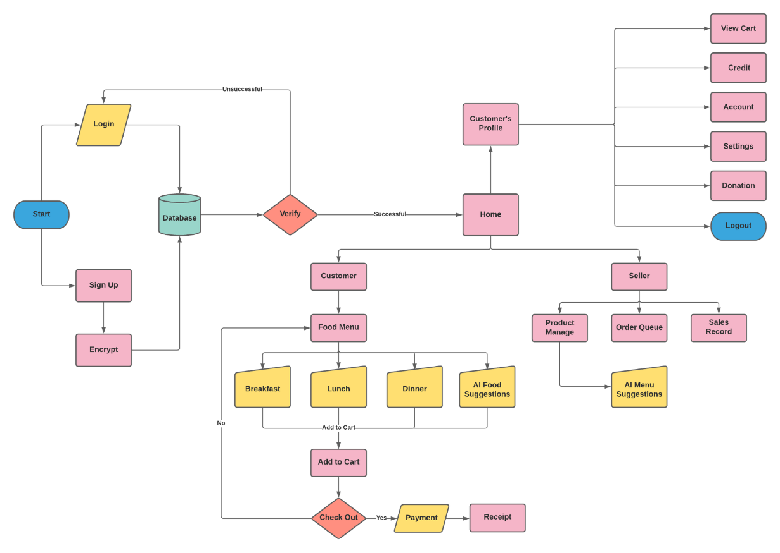
The application starts with 2 major requirement which is "Register" and "Login". In Sign-up you will create your account by filling up the form, then data will be added in the Database. Another is "Login"; here you can access the application by signing in using your ID (student number for students and employee number for professor, executives, and CCA staffs) and password.
When you successfully signed in you will see in the dashboard the meals category, recommended for you, and top products. In meals category, it holds the breakfast, lunch, dinner, snack, and all products if customer decided to manually search for meal-by-meal type. At the right top part of the screen, customer can be able to make a change in their profile by clicking the edit button below logout. You’ll see at the bottom part of the dashboard the home, my purchases, my cart, my ccredit and donate. In my purchase, it indicated there the purchase history of the buyer like in queue, to pick up, and claimed. In my cart, it has all the items which is coming from a particular seller added in the shopping cart. In my ccredit, the buyer can be able to reload their account to get a promotional credit as what we call canteen credit. Seller will load their customer's credit and customer will pay it depends on their choice of payment. Canteen credit can be able to use as a payment method for future purchase for a particular store. Lastly, the donation, buyer can be able to send a donation via ccredit.
The seller system has 2 categories "Products" for meals in menu and "Orders" for manage orders. All available meals will be put in the Products by the seller and within 2 weeks, the AI (Artificial Intelligence) Menu Suggestion will suggest the seller to lower the price or to change the meal that has few sales. The seller will see all the order placed in Order Queue; In queue, to pick up items, and claimed. The payment will be done depending on the payment method which the customer chooses when placing an order. After the ordering process, a QR code will be generated that needs to be scanned by the seller for the customer to claim their order. There will be a Sales Records in which the seller can track and view all the sales per day, week, months, and year.

Figure 2: Conceptual Framework of the Study (Administrative Site)
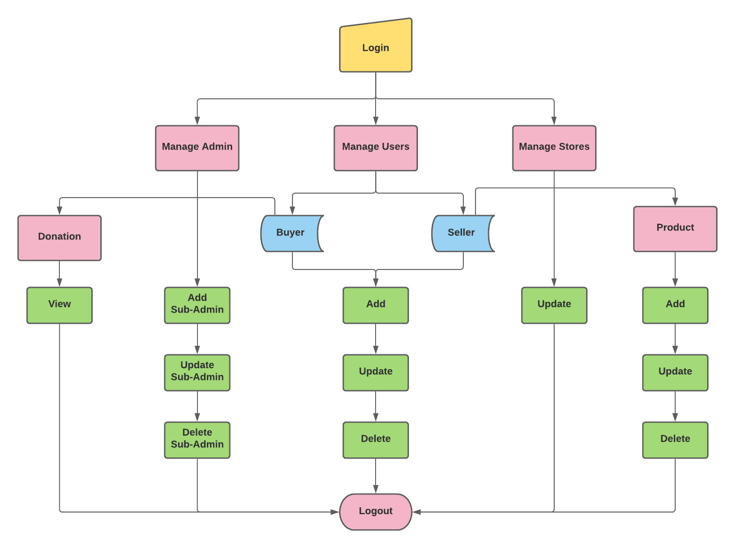
One of the important parts of the system is the Administrative Site where data must be managed by the admin. In administrative site, admin must be able to manage Admin, Users and Store information. Sub-admins can only be added, update and delete by the main admin, to make sure that the changes made in sub-admins is approved by main admin. Admin and sub-admins can manage and view buyer and seller users, and manage stores. Only update can be made in Stores, any adding and deleting changes in stores must be made in sellers tab. For donations, sales and menu, these can be managed as well by the admin.

Significance of the Study
- To the Students. To allow everyone to make transaction in canteen without being huddled, because you can make an order online and pay it thru cCredit or Pay on site.
- To the Officials (Professors, Executives and Staffs). To help the officials order food easily, also they do not need to rush their order because there are no people around them. The paying method is thru online like cCredit or pay on site.
- To the Sellers. This application will serve as a platform in selling food online, it will help sellers to prepare meals without rushing and will prevent in providing the wrong order because of panic and confusion. This will also help the products to be consume instantly since there's an option to sell food that has low sales at a lower price.
- To the School. To help the school maintain its orderliness, to provide a solution, and to benefit the school's students, officials, and canteen vendors.
- To the Researchers. To help both consumers and producers in terms of making transaction in the canteen. Researchers would like to extend the generosity and kindness of CCA students and Official by making a Donation Box as a sub-feature, in which the users can use it to buy a meal for someone who needs it.
- To the Future Researchers. To give them some foundations and ideas to help them build their own or improve this study.

Definition of Terms
- Aggregate – it is an output when combined different element
- Artificial Intelligence (AI)- it refers to the replication of human intelligence in computers that have been programmed to think and act like humans.
- Canteen Credit (cCredit) - Customer must be able to reload their account to get a promotional credit as what we call canteen credit.
- E-Commerce (Electronic commerce)- it refers to which is carried out by electronic means over the Internet.
- Electronic Mail (E-Mail)- it is a free web-based e-mail service that has enough storage for messages and search the specific messages.
- Firebase Database – it is software where you can store and sync your data and it is cloud-hosted NoSQL database.
- Huddled – it can control something or hold something with your hand.
- International Organization for Standardization (ISO) – it is the way to ensure the efficiency, safety, and quality of products, service, and system and it is also a non-governmental organization.
- LinkedIn – it is social networking website where you can find a new job base on your profession.
- Netflix- a subscription-based software where you can watch and download T.V series and movies.
- Quick Response Code (QR Code) - if the file is too big, when you scanned the QR code; you can easily access to it.
- Non-technical – A person who is not knowledgeable on technology.

METHODOLOGY
AI Ordering Application for City College of Angeles includes different technical models, algorithms and analytics used in conducting the study. The techniques, plans and strategies used in planning, designing and development were systematically analyze and discussed.

Algorithms
Figure 3: First in First Out (FIFO) Algorithm for Buying Part
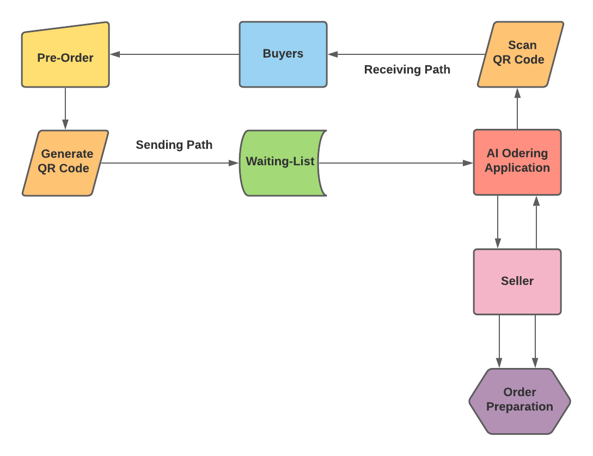

- First in First Out (FIFO) Algorithm for Buying Part
The algorithm that used in Buyer is Scheduling Algorithm First In First Out (FIFO) because this is an online ordering system. The buyer can pre-order and will receive a QR code as a receipt. Once the order is place, they'll be put in Waiting-List (Order Queue) and whoever is on top of the waiting list will be prioritized to prepare by seller. After the preparation is completed, there will be an automatic notification when the order is ready to be pick up, and buyer can only claim the order using QR code. In the FCDS code in the application, the hierarchy of the order is based on the timestamp of the order. Which means the earlier the buyer pushes his/her order the earlier it will be processed. The date/time of the order after being process is converted into milliseconds. Thus, the first order has the least miliseconds and which will be the first one to be processed.
HashMap<String, String> map = new HashMap<>();
map.put("orderID", timeStamp);
map.put("date", date);
map.put("time", time);
map.put("status", status);
map.put("payment", payment);
map.put("totalCost", totalCost);
map.put("orderBy", orderBy);
map.put("orderTo", storeUID);
map.put("storeName", storeName);
map.put("buyerUID", firebaseAuth.getUid());
map.put("buyerFirstname", buyerFirstname);
map.put("buyerLastname", buyerLastname);
DatabaseReference orderRef=firebaseDatabase.getReference("Orders").child(timeStamp);
orderRef.setValue(map).addOnSuccessListener(new OnSuccessListener<Void>() {
@Override
public void onSuccess(Void unused) {
for (int i = 0; i < productList.size(); i++) {
orderRef.child("items").child(productList.get(i).getCartID())
.setValue(productList.get(i));
}
// prepareNotificationMessage(timeStamp, storeUID);
createNotification(storeUID,timeStamp);
}
});

Figure 4: First Come First Serve (FCFS) Algorithm for Selling Part
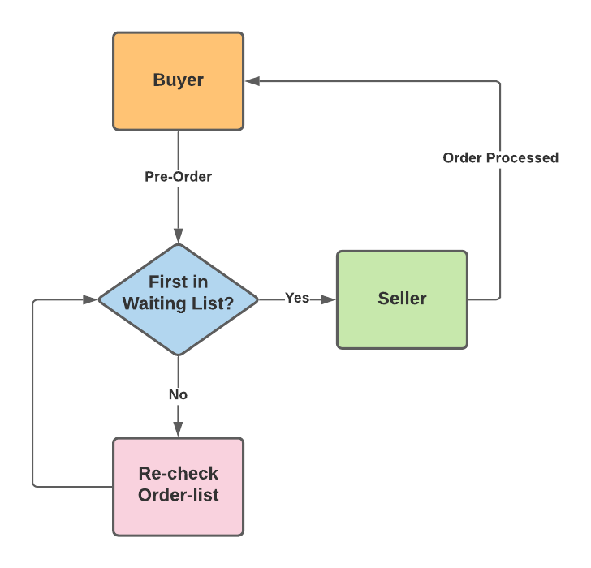

- First Come First Serve (FCFS) Algorithm for Selling Part
The algorithm used in seller is First Come First Serve (FCFS). When the pre-order has been done by the buyer, it will automatically receive by the seller. When claiming the order, you must present the QR Code receipt that was generated and have the seller scan it, once it was scanned successfully, you can finally claim your order. In the FCFS code in the application, there's if statement that filters who owns the order, and it will be indicated their millisecond. Whoever has a lower value of millisecond, they're the one who push the order early, which will be put at the top of In queue tab in the application, and seller will be able to serve the buyer who made the purchase early.

private void loadInQueue() {
productList = new ArrayList<>();
DatabaseReference orderRef=FirebaseDatabase.getInstance().getReference("Orders");
orderRef.addValueEventListener(new ValueEventListener() {
@Override
public void onDataChange(@NonNull DataSnapshot snapshot) {
productList.clear();
for (DataSnapshot ds: snapshot.getChildren()) {
String sellerUID = ""+ds.child("orderTo").getValue();
if (sellerUID.equals(firebaseUser.getUid())){
InQueueModel inQueueModel = ds.getValue(InQueueModel.class);
productList.add(inQueueModel);
}
adapterInQueueSellerOrder=new AdapterInQueueSellerOrder(SellerInQueueActivity.this, productList);
rvInQueue.setAdapter(adapterInQueueSellerOrder);
adapterInQueueSellerOrder.notifyDataSetChanged();
}
}
@Override
public void onCancelled(@NonNull DatabaseError error) {
}
});
}

Figure 5: Ranking Aggregation Algorithm for Product
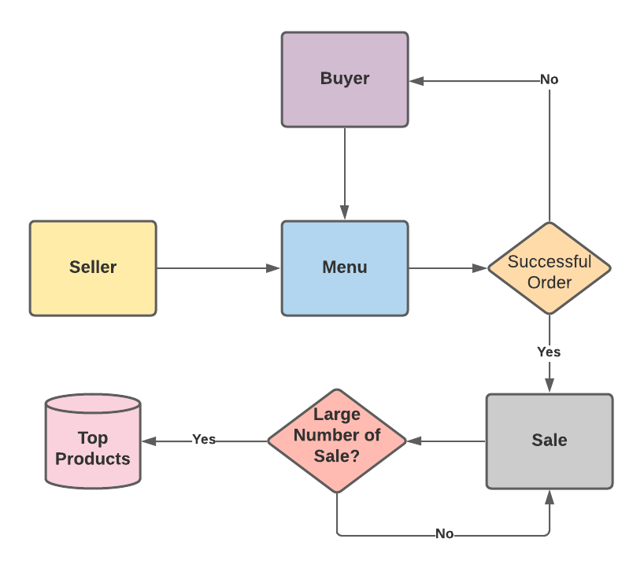

- Ranking Aggregation for Products
The algorithm of the product is rank aggregation. In the application, the seller has an option to add a product which is displayed in the menu. Through the menu, the buyer has an option to choose which product or meal they would like to buy which will be converted as a sale. A product that has a large number of sales will be put as a top product. In the rank aggregation code in the application, there is a sorting part in the firebase based on the sales count of a product. If there is a product that has a same sale.

private void getTopProduct(){
ArrayList<ProductModel> productModels = new ArrayList<>();
DatabaseReference productRef = firebaseDatabase.getReference("Products").child("allSellerProducts");
productRef.orderByChild("salesCount").limitToLast(1).addListenerForSingleValueEvent(new ValueEventListener() {
@Override
public void onDataChange(@NonNull DataSnapshot snapshot) {
for (DataSnapshot ds: snapshot.getChildren()) {
productModels.add(ds.getValue(ProductModel.class));
}
if (productModels.size()>0){
rlInvi2.setVisibility(View.GONE);
rlTopProduct.setVisibility(View.VISIBLE);
tvTopProductFoodTitle.setText(productModels.get(0).getFoodTitle());
tvTopProductStoreName.setText(productModels.get(0).getStoreName());
tvTPDiscountPrice.setText(productModels.get(0).getDiscountPrice());
tvTPOriginalPrice.setText(productModels.get(0).getPrice());
tvTPCategory.setText(productModels.get(0).getCategory());

Glide.with(getApplicationContext())
.load(productModels.get(0).getProductImage())
.centerCrop()
placeholder(R.drawable.food).error(R.drawable.ic_baseline_storefront_24)
.into(imgTPFoodImage);

if (productModels.get(0).getDiscountAvailable().equals("true")){
tvTPDiscountPrice.setVisibility(View.VISIBLE);
tvTPOriginalPrice.setPaintFlags(tvTPOriginalPrice.getPaintFlags() | Paint.STRIKE_THRU_TEXT_FLAG);
tvTPOriginalPrice.setTextColor(tvTPOriginalPrice.getContext().getResources().getColor(R.color.grey));
}else{
tvTPDiscountPrice.setVisibility(View.GONE);
}
imgTPaddToCart.setOnClickListener(new View.OnClickListener() {
ArrayList<CartModel> cartModels = new ArrayList<>();
@Override
public void onClick(View view) {
DatabaseReference cartRef = firebaseDatabase.getReference("AllCarts").child(userProfile.getUid());
cartRef.limitToFirst(1).addListenerForSingleValueEvent(new ValueEventListener() {
@Override
public void onDataChange(@NonNull DataSnapshot snapshot) {

if (!snapshot.exists()){
Intent intent = new Intent(getApplicationContext(), AddToCartActivity.class);
Bundle bundle = new Bundle();
bundle.putString("stallName", productModels.get(0).getStoreName());
bundle.putString("foodTitle", productModels.get(0).getFoodTitle());
bundle.putString("price", productModels.get(0).getPrice());
bundle.putString("discountAvailable", productModels.get(0).getDiscountAvailable());
bundle.putString("discountPrice", productModels.get(0).getDiscountPrice());
bundle.putString("discountNote", productModels.get(0).getDiscountNote());
bundle.putString("icon", productModels.get(0).getProductImage());
bundle.putString("description", productModels.get(0).getDescription());
bundle.putString("category", productModels.get(0).getCategory());
bundle.putString("storeUID", productModels.get(0).getStoreUID());
bundle.putString("productID", productModels.get(0).getProductID());
intent.putExtra("productData", bundle);
startActivity(intent);
}else{
for (DataSnapshot ds: snapshot.getChildren()) {
CartModel cartModel = ds.getValue(CartModel.class);
cartModels.add(cartModel);
}
String storeID = cartModels.get(0).getStoreUID();
if (storeID.equals(productModels.get(0).getStoreUID())){
Intent intent = new Intent(getApplicationContext(), AddToCartActivity.class);
Bundle bundle = new Bundle();
bundle.putString("stallName", productModels.get(0).getStoreName());
bundle.putString("foodTitle", productModels.get(0).getFoodTitle());
bundle.putString("price", productModels.get(0).getPrice());
bundle.putString("discountAvailable", productModels.get(0).getDiscountAvailable());
bundle.putString("discountPrice", productModels.get(0).getDiscountPrice());
bundle.putString("discountNote", productModels.get(0).getDiscountNote());
bundle.putString("icon", productModels.get(0).getProductImage());
bundle.putString("description", productModels.get(0).getDescription());
bundle.putString("category", productModels.get(0).getCategory());
bundle.putString("storeUID", productModels.get(0).getStoreUID());
bundle.putString("productID", productModels.get(0).getProductID());
intent.putExtra("productData", bundle);
startActivity(intent);
}else {
Snackbar.make(imgTPaddToCart, "You cannot add product from two different seller/stall.", Snackbar.LENGTH_LONG).show();
}
}
}

@Override
public void onCancelled(@NonNull DatabaseError error) {
}
});
}
});

}
}
@Override
public void onCancelled(@NonNull DatabaseError error) {
}
});
}

Research Design
Online Ordering System nowadays is very important because it lessen the hassle of every people and it has fast transaction. (Patel, 2015) Also, Online Ordering System is the way to slow the transmission of coronavirus and because of this there is no room to wait your order long because you can order in advance to avoid long queuing. (Ramli et al., 2020) This is the reason why the researchers come up this study.
The research design that used in this study is Descriptive Research Design to know the majority problem of every single buyer. As we gather the information, this design ensures the outcome how hassle, and what struggles of person experiencing in ordering onsite in City College of Angeles canteen. In addition, Descriptive Research Design focus on the feelings of the buyer like; what is main reason of having long queuing, and when it most likely the problem happening. To be more specific, the researchers will be conducting a survey to some students, teachers, and other school vendors.
Our research is based on quantitative; we gather responses and data from the possible user of the application. We determine the respondent’s understanding in using the application by analyzing and calculating the mean of the numerical data. With the evaluation, it helps us to know if the application is fit for the users’ usage and understanding.

System Development Methodology
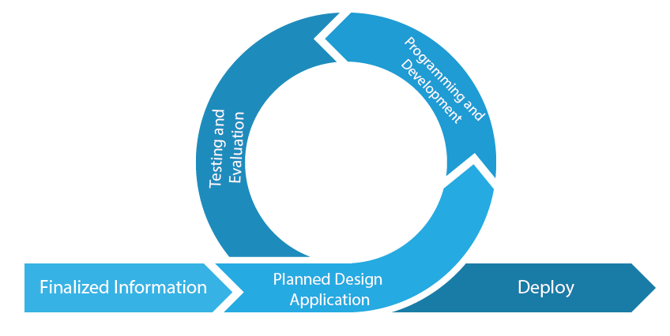
Figure 6: Agile Model

Finalized Information
The researchers will need the necessary information of buyer and seller users, and reports. Buyers can pre-order a meal online so that it wouldn't be hassle falling in line in a crowded canteen and more efficient in buying a meal. Therefore, the school canteen needs to have an application intended to pre-order a meal online and suggest a menu for meals base on PH’s time zone.
Planned Design Application
The researchers should have steps in applying the acquired information to make sure that the purpose and efficiency of the system are achieved. Researchers were able to planned the proper design required in the application including Sign In, Register, AI Menu Suggestion, Buying and Selling UI, Administrative Site and other features.

Programming and Development
The researchers used Java to develop the AI Ordering Application for City College of Angeles since it is application-based system and administrative site is a web-based system in which java can make a platform for both this will ensure the flexibility and efficiency of the system.
Testing and Evaluation
Testing and evaluation will determine if the system is ready to be deployed or not. Testing the system is an important part of the development process to know if there are bugs and other issues that needs to be fixed. There will be testers and evaluators which are some IT Experts and some possible users of the system that will help the researchers to go through this process. Their opinions and suggestions about the system will be considered and it will be analyzed by the researchers, if it is truly needed, the researchers will go back to designing process in which they will add or include those features or enhancements. If there are no other features that need to be added or bugs that need to be fixed, it will now go to the deployment phase.
Deployment
In this phase, once the application achieved and satisfies all the functional requirements, and does not need any more revisions. It will now be ready for implementation and public use.

Participants
The participants included in the study are students, officials, and school vendors. The first requirement of the study was that, the participant must be currently working or studying in City College of Angeles. These participants are picked as respondent in the study because they can provide the ample feedbacks about the queueing system and payment methods in the school canteen. The study has 122 Non – I.T. and Three I.T. Experts with a total of 125 respondents.
The sampling technique used in the study is Convenience Sampling is the method we chose. Convenience sampling acquire a respondent through the member of the population, and it is only used if the researchers don’t have a list of the information of the participants. The pandemic makes the availability of the participants inconvenient, whoever willing to respond in the study is included in the said parameters (Etikan & Bala, 2017). Overall, we have conducted 122 participants.

Procedure
The Artificial Intelligent Ordering System researchers used the following methods and procedures to come up to this study:
- Survey
Is used in this study because it is relatively effective for distributing, it can acquire large information from respondents, and it can be answered through online. Large-scale population-based data collecting has always been a part of survey research. The primary goal of this type of survey research was to swiftly gather information about the characteristics of a big group of people of interest. (Julie Ponto and Oncol, 2015). (See Appendix A)
- Web Researches
This study relies also on web researches to complete the study. Internet researches helps us to understand about Artificial Intelligence and online food ordering system. Through the use of internet research, we found out that ordering systems makes more efficient for processing orders and manage dynamic online menu. (Patel, 2015) Which is essential information for developing user friendly application interface.
- Evaluation Questionnaire
The researchers will be having three IT experts who will evaluate the proposed system.
Once the application is completed and ready to release, the IT experts must answer the evaluation instrument to evaluate the application. For non-IT experts, the researchers decided to use google forms for questionnaires, to ensure that every participant can access the questionnaires (ISO-25010-Assessment-tool - IT Experts).
There are eight different criteria in the ISO Assessment-Tool which are Functional Suitability, Performance Efficiency, Compatibility, Usability, Reliability, Security, Maintainability, and Portability.
- Functional Suitability - is defined as the attributes of a product or system performs functions that meet the stated or implied requirements.
- Performance Efficiency - refers to how well a product or service performs in relation to the quantity of resources it consumes.
- Compatibility – is referred to the ability of a product, system, or component to share information and execute its needed activities while maintaining the same hardware and/or software environment.
- Usability - usability of a product or system relates to how often it can be utilized to fulfill particular targets effectively, efficiently, and consistently.
- Reliability – is referred to the capacity of a system, product, or component to perform stated functions under given condition.
- Security – the security of a system or application refers about how well it protects information and data from security flaws.
- Maintainability – it refers to a product's or system's ability to be adjusted to enhance, correct, or adapt to changes in the external environment or requirements.
- Portability – it is referred to the ability of a system, product, or component to be moved from one environment to another

Data Analysis
The research conducted an online survey by encouraging all participants to take part through to an online messaging platform. Respondents were politely asked to answer all the required questions sincerely and to take the survey seriously in order to accomplish the goal of figuring out what are the causes of queueing issues in CCA’s Canteen.
Frequency Count Distribution. Is a representation, either in a graphical or tabular format that represents the information of findings within a specified frame. The size of the interval is determined by the data being analyzed and the analyst's objectives.
Percentage Distribution. It was utilized as a clear measurement to depict the relationship of a couple of factors as a percentage of the total frequency equated to 100. It is a particularly useful method of displaying the frequency of survey results and other data. Tables, bar graphs, and pie charts are frequently used to display percentage frequency distributions. The general formula is as follows:
$P=\frac{F}{N}$ $× 100$
Where: P = Percentage
F = Frequency
N = Number of respondents
Arithmetic Mean. Educational researchers frequently compose multiple Likert-type items, aggregate them into a "survey scale," and then compute a total or mean score for the scale items (Sullivan and Artino, 2013). It is demonstrated that depending on the generating functions used, there are an endless number of useful forms of weighted means and convex functions (Kadak and Gurefe, 2016).
To get the overall average of weighted means, the researchers will apply this formula.
Weighted Mean Formula: Mean = TP/ TR
(NV * scale1) + (NV * scale2) + (NV * scale3) + (NV * scale4) + (NV * scale5) / TR
Where:
NV = Number of Votes, TP = Total Sum of the Product, TR = Total number of Respondents
Likert Scale. Is a rating scale that is commonly used in questionnaire-based research. It is the most commonly used approach to scaling responses in survey research, and the terms are frequently used interchangeably with rating scale.
Table 1: Likert Scale
Description | Numerical Rating
Excellent | 5
Very Good | 4
Good | 3
Fair | 2
Poor | 1
As seen in the table above, it displays the rating scale for the questionnaire. After seeing a walk-through video of the application given by the researchers, the respondents will grade it based on their observations. In survey research, Likert Scale questions are popular because they make it simple to operationalize personality traits or perceptions.
Likert scale Interpretation the Evaluation Result. Results that were collected from the testing and assessments will be use to interpret during the evaluation. In research projects, Likert scales are useful. Typically, there are five response categories ranging from 5 for Excellent, 4 for Very Good, 3 for Good, 2 for Fair, and 1 for poor will be the numerical value for each scale level that will be used on the evaluation. Because Likert scales are one-dimensional, it's key to concentrate on what you're trying to measure. Afterwards, create a list of potential scale items and have a panel of judges rate them (Croasmun and Ostrom, 2021).
Table 2: Likert Scale Equivalent
Description | Numerical Rating
Excellent | 4.20 – 5.00
Very Good | 3.40 – 4.19
Good | 2.60 – 3.39
Fair | 1.80 – 2.59
Poor | 1.00 – 1.79

The corresponding ratings to the outcome of reviewing the AI Ordering Application for City College of Angeles are shown in table 2 above. The researchers will utilize ISO 25010 as an assessment criterion for the survey on analyzing the observations on the application by the participants, which will include three IT experts. (See Appendix C) Assign a point value to each response ranging from 1 to 5, depending on the number of available responses. On the Excellent or Poor side, some survey creators do not add the "somewhat" option. The most common values for the alternatives are "Poor" (1 point) and " Excellent" (5 points).

Design and Implementation

Requirement Specification Analysis
The purpose of the application is to lessen your time for long queuing. The application can give you the chance to help some people who do not have enough budget to buy meal. Simply creating and logging in your account you can see what are the features of the application. This section will also discuss all of the features that the user will see on the proposed application. These are:
Buyer Module - Under this module, the features below are the features that the user will encounter in the application if they are registered as buyer.
- Menu – The menu features under buyer are meal category, recommended products, and top product. In meal category, the buyer will have an option to view the meal depending on their categories. While, on the top products, it is depending on a meal that has a highest number of purchased.
- AI Menu Suggestions – In this feature, you will see the products recommended for you. The application will suggest a meal to the buyer depending on the category based on time.
- My Purchases – In this feature, you will see “In Queue”, “To Pick Up Items”, and “Claimed”. Right after the buyer made a purchased, it will show up in the “In Queue”, in here you will see order number, date, time of purchased, store name, mode of payment and total. While on the “To Pick Up Items” it will show up the order that is tagged as “Ready to Pick Up” by the seller. And lastly, in the “Claimed”. The user will see all of their orders’ history.
- My Cart – In this feature, every meal you added in your shopping cart will show up here. The cart won’t allow the user to add an item in different sellers.
- cCredit – In cCredit, the user can view their credits on each seller. The user will have an option to view their credits’ history. This can be used as a payment when the user is making a purchase. If the user decided to make a purchase using payment on site there will be a credit that will be deducted in the cCredit to prevent unclaimed orders, the cCredit that is being deducted will be refunded if the buyer claimed the order and pay it on cash.
- Donation – In donation, the user will have an option to donate and view all the donators on the history tab. The user can use the donation as a payment method if there’s available funds on the donation.
- Generating QR-Code – In this feature, the QR will be generated once the seller tagged the order as ready to pick up. This will be use if the buyer is claiming their order.
Seller Module - Under this module, the features below are the features that the user will encounter in the application if they are registered as seller.
- Add Product – In “Add Product”, the seller will fill up the information needed for the product, like; food image, meal-name, description, category, and price. It depends on the seller if they decided to add a discount to a particular meal. This discounted feature is mostly used when a meal has a low sale.
- Menu – Every product that is added by the seller will automatically show up on their menu lists. The seller can edit the meal details and they can delete the meal if it is already out of stock.
- Orders – The seller will see all the “In Queue” meals. This is the fastest way for the seller to see all the orders that has been purchased.
- Store Orders – In this feature it will show up all “In Queue”, “To Pick Up” and “Claimed” orders. In “In Queue”, this is the waiting list of all new orders, in “To Pick Up” this is where the seller will see all the order they tagged as ready to pick up. Lastly, the “Claimed” you will see all the order history that is being claimed.
- Scan QR Code – You will see the scan QR in “To Pick Up” feature, they scan the QR Code once the buyer is picking up the order.
- Canteen Credit – The seller will have an option to load a buyer by using their buyer I.D and credit amount. Once loaded the seller can see the transaction of the credit history. This Canteen Credit can be used as a payment method of buyer, exclusive only on a particular store.
- Store Sale – This is where the “Top Product”, “Lowest Sale Product” and “Total Sales”. In the “Top Product”, it has the highest number of purchased. While on the “Lowest Sale Product” it has the least number of sales. In the “Total Sales” it is calculation of the pay on site and cCredit sales.
Administrator Module - Under this module, the features below are the features that the user will encounter in the application if they are authorized as Administrator.
- Buyer - In this feature the admin can add, edit, and delete a buyer directly on the admin site. This feature will only be used as an alternative option if the user has experienced unforeseen bug or error in the application, if the user is non-technical person or if the user is having difficulties in using the application on the buyer module.
- Seller - In this feature the admin can add, edit, and delete a seller directly on the admin site. This feature will only be used as an alternative option if the user has experienced unforeseen bug or error in the application, if the user is non-technical person or if the user is having difficulties in using the application on the buyer module.
- Products – In this feature, the admin can only view the products of the seller but not authorized to make alternations to the details of the products.
- Donation – In this feature, the admin can view the list of donators but not authorized to make alternations to the donators’ information or change the value of donations.

System Design and Specifications
The Artificial Intelligent Ordering System theoretically can be used fully functional to the android devices has 4 or more central processing units, 2 or more RAM storage, has internet access.
User Interface Design
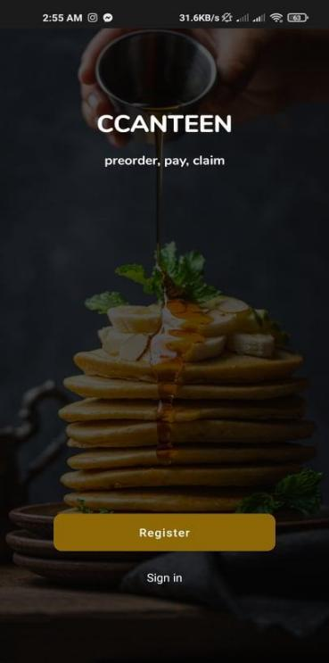
User Interface (UI) Design is concerned with envisioning what users may need to do and ensuring that the interface contains elements that are simple to access, understand, and use in order to facilitate those actions. Interaction design, visual design, and information architecture are all combined in UI.

Figure 7: Front Page of CCanteen
The first picture is the register, so you need to register first as buyer/seller. Once you register yourself as buyer you will proceed to user interface for buyers

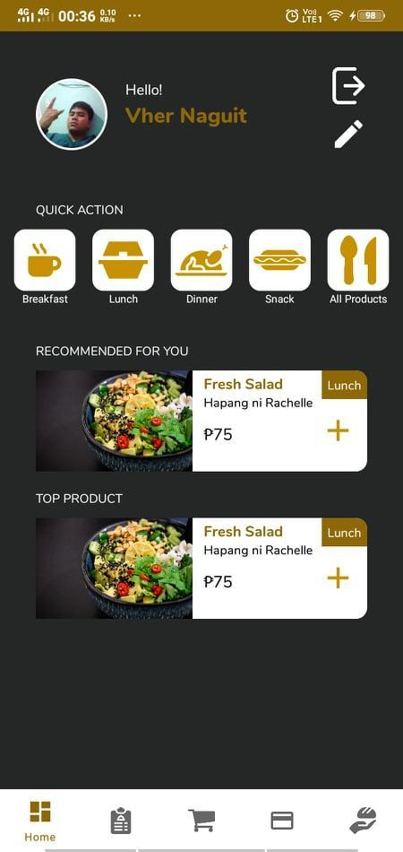

Figure 8: Buyer’s Menu of CCanteen
In buyer user interface, the buyer can now see the edit profile, meals and queuing system. In "My cart" the buyer can view his/her meal to check if there is missing or not. In this picture or "In Queue Items" both seller and buyer can see this to check the items ordered.

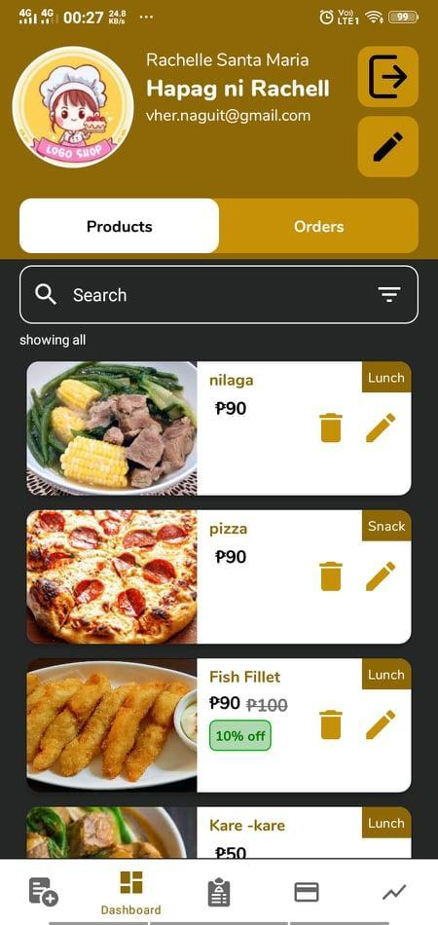

Figure 9: Seller’s Menu of CCanteen
The seller interface shows the orders purchased by the seller and it shows all of his/her menu. Then it has the records and daily sales in the button. This "Add product" for the seller is the way of creating meal by filling it all the needs then once the seller taps the "Add Product" the product will post to buyers’ menu. This Claimed Items will show all the item that being claimed by the buyers.

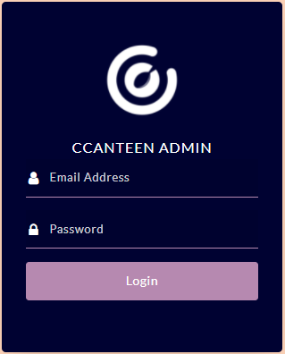

Figure 10: Admin Site Login
This image is where the admin user will login in, it requires email address and password of the admin user.

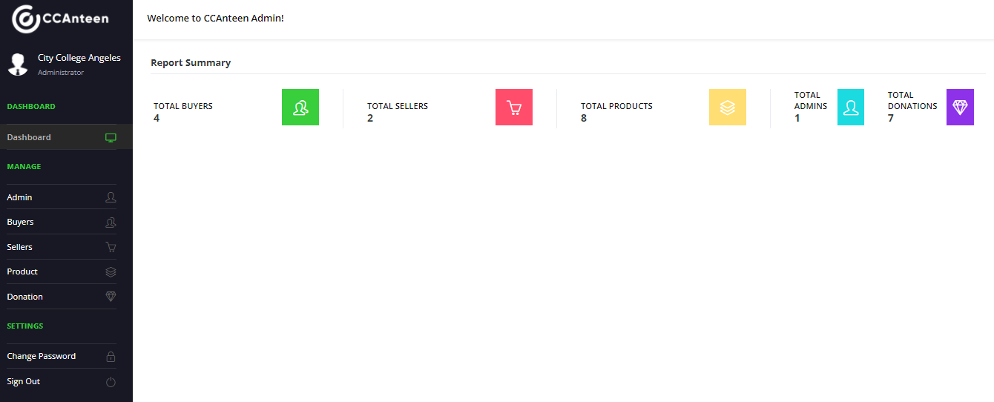
Figure 11: Admin Site Dashboard
Admin site dashboard is where you will see the total buyers, sellers, products, admins and donations in the application. The dashboard will get the data in the firebase.

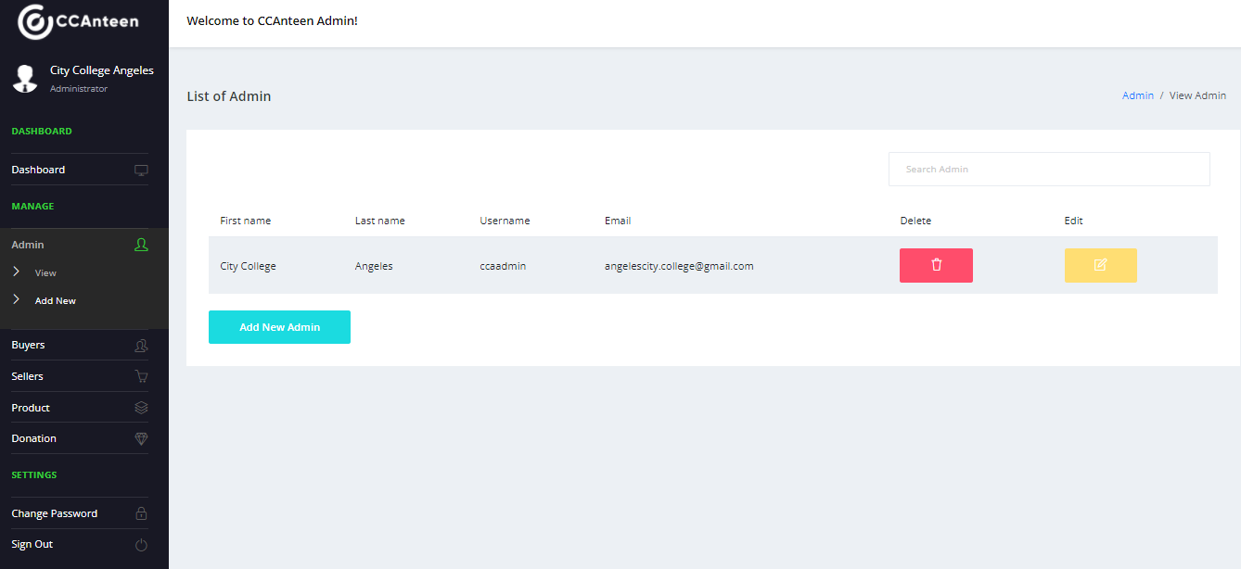
Figure 12: Admin Site View Admins
Admin site will view all the admins who is managing the data for the application. Aside of viewing the data, the admin can create another admin user which will be the sub-admin.
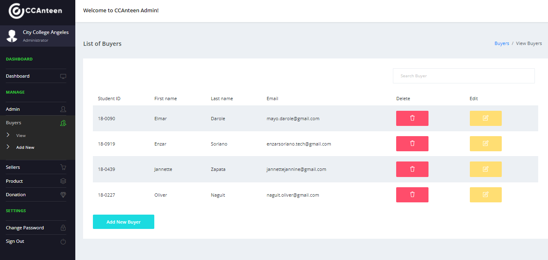
Figure 13: Admin Site View Buyers
Admin user can view buyers list. The admin user can manage the data for buyers like add, edit and delete.
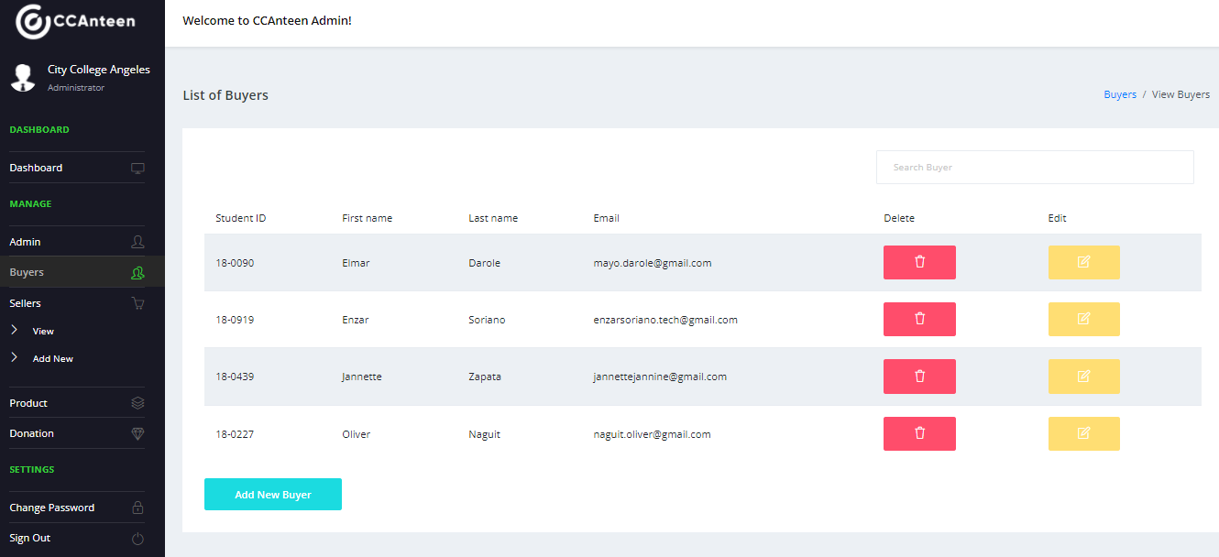
Figure 14: Admin Site View Sellers
Just like the view buyers, the admin user can view sellers list. The admin user can manage the data for sellers like add, edit and delete.

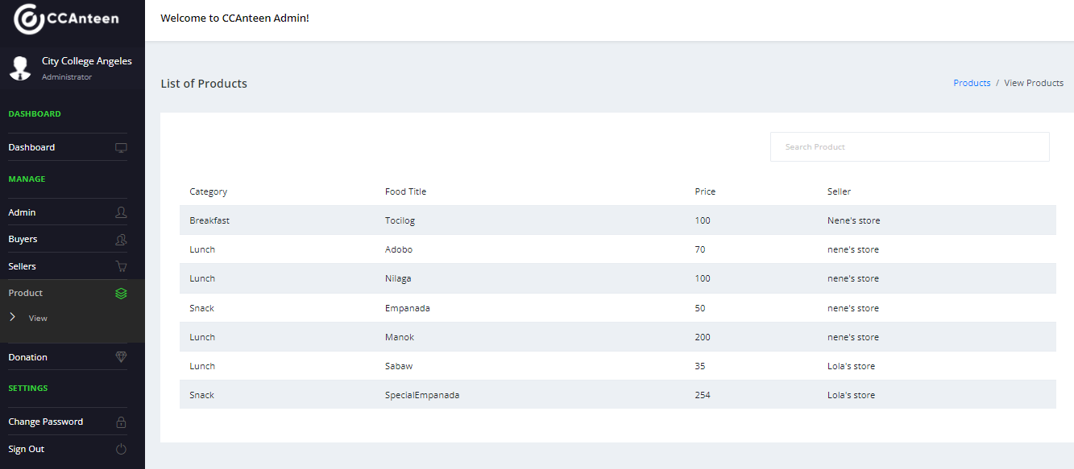
Figure 15: Admin Site View Products
The admin user can view the products, we limited the accessing in the products because seller will be the one who will manage the products.
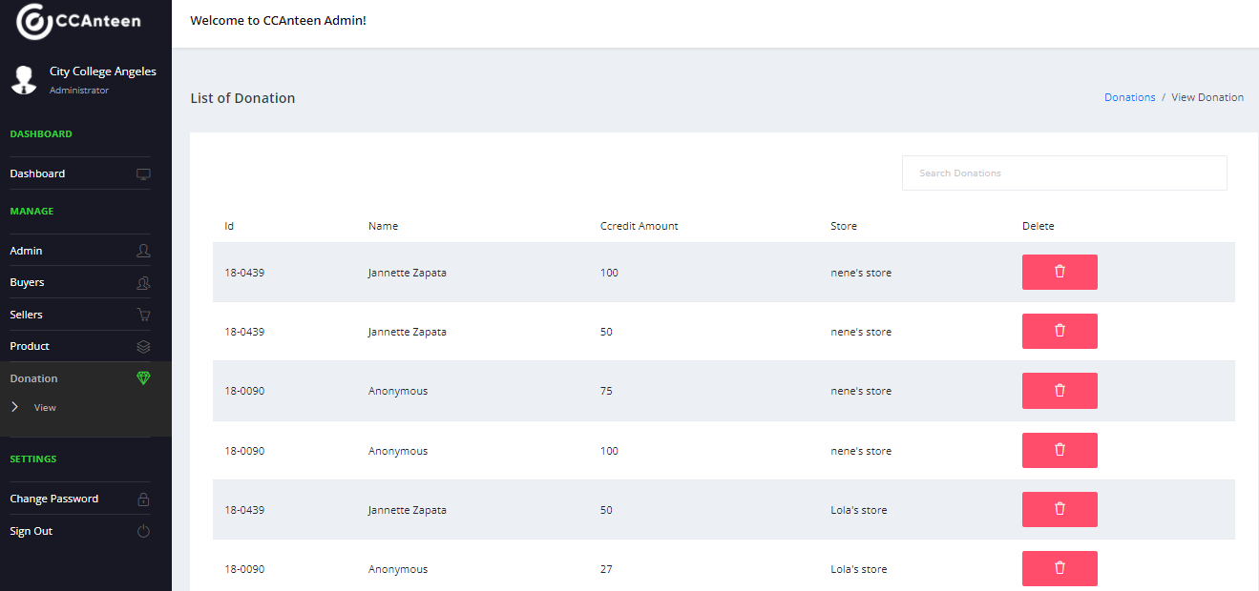
Figure 16: Admin Site View Donations
Just like the view products, the admin user can view the donations, we limited the accessing in the donations because it is associated with money, and the seller must have the only one to add credits to buyers.

Logical Specifications
This section presents the different diagrams used in AI Ordering Application for City College of Angeles. These following diagrams that are used to this study are:
Data Flow Diagram
- Context Level (Level 0) Data Flow Diagram.
The process of Context Level (Level 0) DFD of the study starts with 2 entities called buyer and seller that is being managed by the Admin. Customer and Seller must provide the details and be saved in the database. Seller must create a menu suggestion that will be used by the buyer in doing the pre-order. Once the seller successfully created the menu it will be put in the database, the buyer will use it to do the pre-order and once done, buyer may now proceed to check-out Right after the check-out buyer will receive a receipt and it will be put also in the database. With the receipt, customer will be able to claim the order once the order is processed and ready to be claim, and then order will be completed. All data gathered from AI Ordering Application will be send to the admin, and it will be available to the admin site which can be also manage by the admin user. (See Appendix I)
- Level 1 Data Flow Diagram.
Level 1 Diagram is one level further down than the level 0 diagram. In this diagram, it has to be balanced, meaning it needs to have the same number and label in the inputs and outputs to our level 0 diagram. The first step to it is we need to confirm if the order is getting process. Admin will manage the tables of seller’s and buyer’s information. The seller must add products to the menu list in order for the customer to have the will to choose. Once the customer added items to the shopping cart, once the order is placed the seller will be able to see the list of the items in the order. However, before the order will be placed the customer must choose their desired payment method between cCredit and on hand cash. After the customer have placed his/her order, the seller will receive the order list and the customer can claim their order. (See Appendix J)
Use Case Diagram
This diagram depicts the function and interactions of the user, mobile, and device. In the diagram, the customer can navigate the menu and place an order, with the option to view their order as "In Queue," "To Pick Up," or "Claimed." The customer can also view cCredit, where he or she can see their current balance, which they can also use to pay and donate. The seller, on the other hand, can navigate the menu and see the order placed; they also have an option on what the customer can see under the placed order, but unlike the customer, the seller has a unique feature where they can view their weekly sales, top product, and lowest sales. It also displays their current sale balance and available cCredit there. Finally, the admin site can manage the information of buyers, sellers, products, and donations. (See Appendix K)
Flowchart
In this section, it shows the overall flowchart of the study, in which it contains the Registration, Sign In, Buyer and Seller Account and Administrative Site. Both buyer and seller need to register to create an account, they have to fill up the form by filling up the required fields. Once they finished creating their account, the data will be put into the database that is managed by the Admin. Using your ID number and password, you can enter your account.
In order for the buyer to make a purchase they just needed to add all the items they want from a particular seller, which means they cannot add items altogether from different sellers. Once added, they need to go to their shopping cart, if they think that they are done reviewing their order, they can proceed to checkout by clicking the button check out below. After that they need to use a payment method between pay on site or pay using ccredit. Just like the typical traditional store, the system has also pay on site payment method, but on the other hand it also has a unique feature which called "Ccredit". The advantage of ccredit from pay on site is that the customer is no longer needed to go through a lot of steps in claiming their orders, like paying their meals, receiving their change, and you are not adding number of people in the crowd. After placing the order, the order will be put under the "My purchases" on the in queue and after the item is ready to pick up, it will be transferred to pick up items and the customer can get the QR code by tapping the order in the list. The customer will claim the order using their QR code and then the seller will scan it by going to the "pick up items" under their seller account. Once scanned, the seller will be able to find the actual order of the customer in the pickup items list of the seller and the seller will be able to marked the order as claimed. Once claimed, the customer order will be transferred to claimed under "My Purchases".
Administrative site will be handled by assigned admin, which they have an access and can manage the users, store, admin accounts, donations, sales and menu data. (See Appendix L)

Hardware Specification
In this section, the researchers will discuss the computer requirements they used when developing the program, as well as the minimum and recommended specifications for running the application during implementation. It is necessary to use computers with high specifications for development. The minimal and recommended specifications for designing and testing the application are presented in Table 3.
Table 3: Desktop specifications used in development and testing
Specifications | Minimum | Recommended
Operating System | Windows 7 Ultimate | Windows 10 Pro, Version 21H1 or newer
Processor | 2nd generation Intel Core or newer, or AMD CPU with support for a Windows Hypervisor. | AMD Ryzen 5 3400G 3.70 or newer
RAM | at least 4GBof ram | 16 GB or more
Hard drive | at least 50GBof free space or more | 500 GB of free space or more
Monitor | at least 1280 x 800 minimum screen resolution. | HP 19’’ Monitor with 1366x768 resolution, and 60hz refresh rate or higher
Video Card | Integrated Graphics | Radeon Vega Graphics (APU) or newer

Table 4: Smartphone specifications used in development and testing
Specifications | Minimum | Recommended
Android Version | Android 5.1(Lollipop)  API 22 | Android 9.0 (Pie),  API 28 or newer
Processor | Google APIs Intel Atom (x86) | Google APIs Intel Atom (x86) or newer
RAM | at least 500MB | 1536MB or more
Storage | at least 200MB | 800MBor more

Table 5: Desktop specifications used in implementation
Specifications | Minimum | Recommended
Operating System | Windows 7 Ultimate | Windows 10 Pro, Version 2004 or newer
Processor | 1.8 GHz or faster processor. Quad-core or better or newer, or AMD CPU with support for a Windows Hypervisor. | Intel Core i5-2400 3.10GHz  or newer
RAM | at least 3GBof ram | 8 GB or more
Hard drive | at least 50GB of free space | 300 GB of free space or more
Monitor | at least 1280 x 800 minimum screen resolution. | Samsung 19’’ Monitor with 1366x768 resolution, and 60hz refresh rate or higher
Video Card | Integrated Graphics | GeForce GT 710 2GBor newer

Table 6: Smartphone specifications used in implementation
Specifications | Minimum | Recommended
Android Version | Android 5.1(Lollipop)  API 22 | Android 9.0 (Pie),  API 28 or newer
Processor | at least 1.0 GHZ CPU | Octa-core 1.8GHz or newer
RAM | at least 1000MB | 3000MB or more
Storage | at least 200MB | 800MBor more

Software Specifications
An Android application requires resources that aren't part of the source code, such as images, audio files, and anything else related to the app's visual look. The researchers in this study used Java as the primary language for application development using Android studio, Android Virtual Device for coding and testing. HTML and CSS were utilized for design for the admin site, and Visual Studio Code was used for code. Both the application and the admin site make use of Firebase capabilities such as authentication, real-time database, cloud messaging for notifications, and image storage in the cloud. The app is only available for Android smartphones and does not support IOS.

RESULTS
In this chapter discusses the all part of the results. It includes the screenshots of system and application outputs and the different hardware equipment that the researchers use in the study. Also, the evaluation results from the I.T. Experts and non-I.T. experts.

System / Application Outputs
The researchers will show the screenshot outputs of the program in this part. The application outputs images below will show what are the pop-up window that you will encounter in using the application. In these outputs, it includes both android application and web admin.
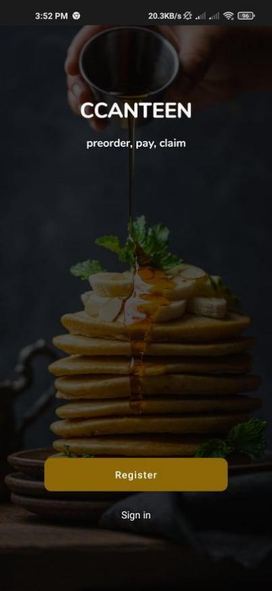

Figure 17: Start up Screen Output
In the figure above, it shows the output when the user completely installed the application.

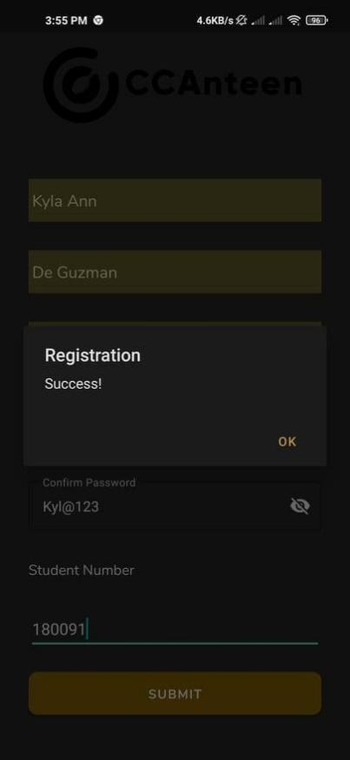

Figure 18: Registration Output
In the figures above, Figure 1 this is the section where the user chooses between buyer or seller. The Figure 2 will show the output “Register Successful” which means the buyer and seller has successful registered an account.


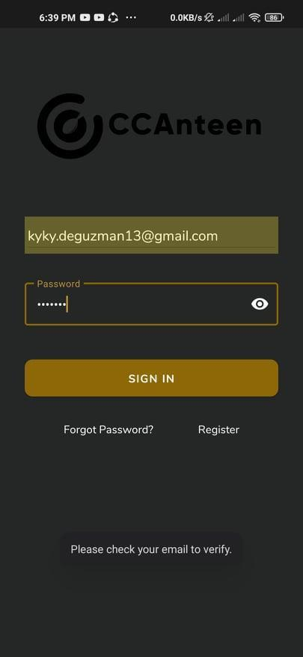

Figure 19: Verification Output
In the figures above, The Figure 1 show before the user is totally signed on the application; the application will require the user to go to the email that the user used to signed in. The Figure 2 show the user if he/she is already verified to the application.

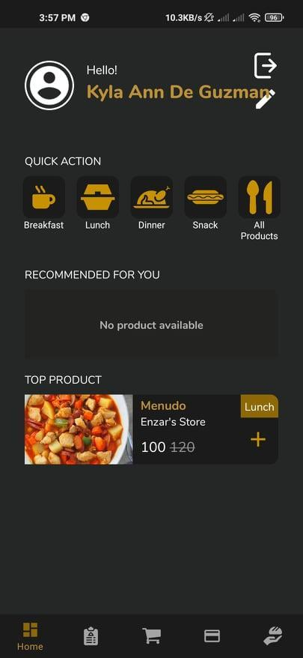
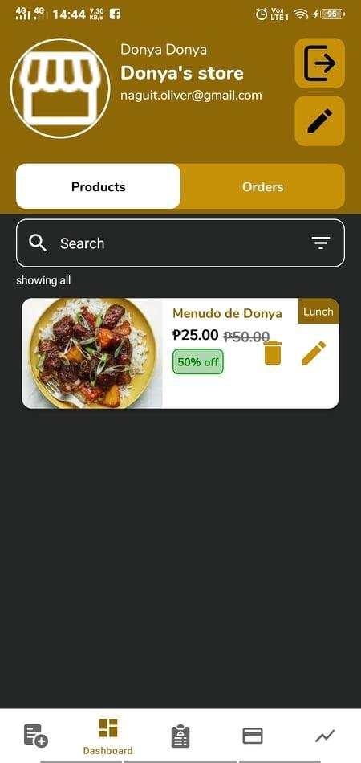

Figure 20: Main Screen Output
In the figures above, Figure 1 shows the user has successfully logged in to the application where the buyer can see and test all the icon of the application. The upper part of the buyer main screen is the profile picture, name, edit profile, and the exit button. There is a “Quick Action” where buyer can choose what meal that the buyer wants to buy by choosing to these categories. Also, there is a “Top Product” that might the buyer want to try and “Recommended for You” that the A.I will recommend the buyer to try also. The figure 2 shows the user has successfully logged in to the application where the seller can see and test all the icon of the application. The top part of the seller main screen is the profile picture, name of store, name of the seller, edit profile, and exit button. After that is the “Product” and “Orders”. The “Product” section is where all the product of the seller can view to check if there is missing to the menu and the right side is the “Order” where the seller can view all the order of the buyer. There is also a “Search Bar” to easily find the meal that the seller created.
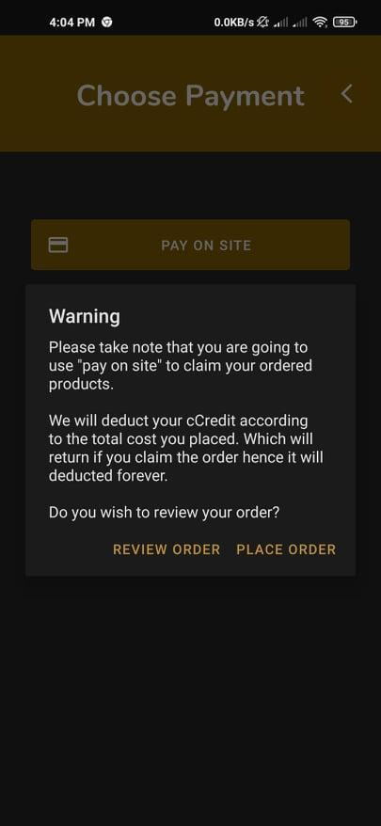
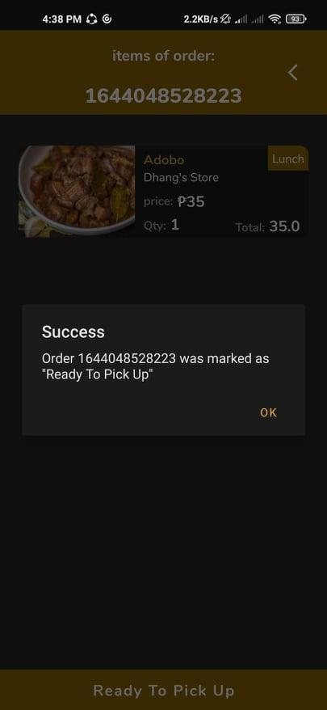
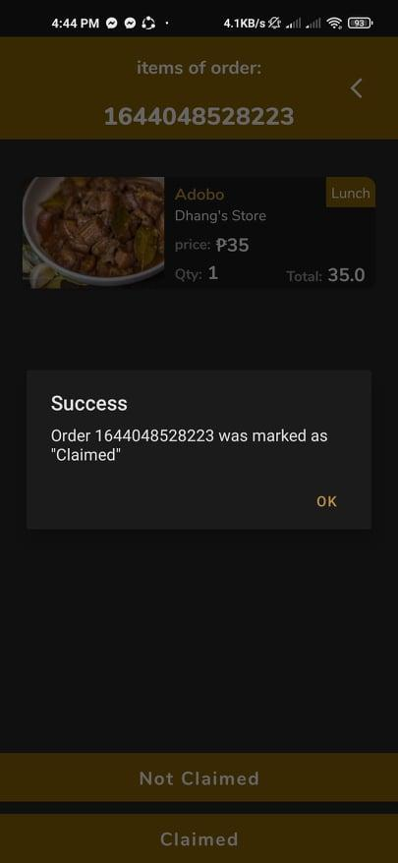

Figure 21: Splash Screen output
In the figures above, Figure 1 show the output when the user chooses “Pay on Site” and the buyer do not have enough credit balance the buyer cannot purchase meal. The Figure 2 show the seller marked the buyer’s meal it will proceed to “To Pick Up” section. The Figure 3 show the user has successfully claimed the order. The application will mark the order as “Claimed”. Both seller and buyer will be notified.
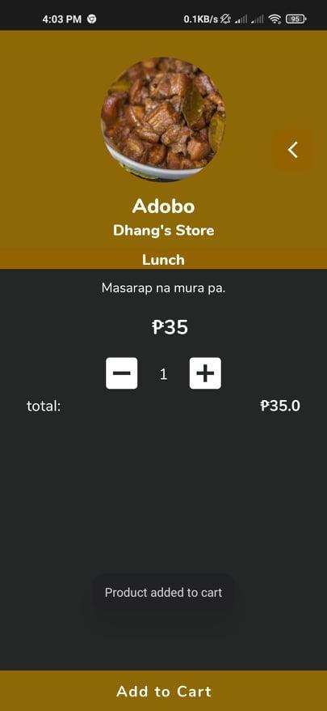
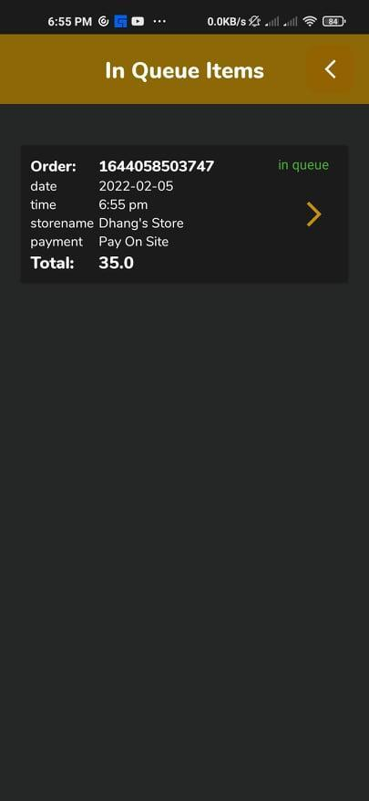
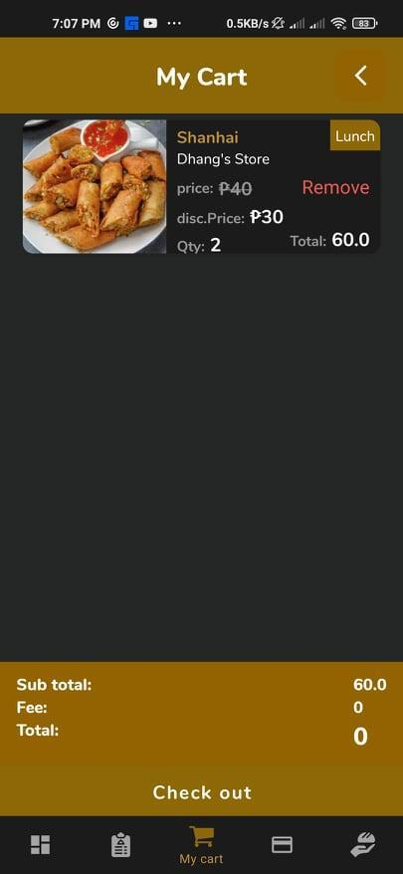

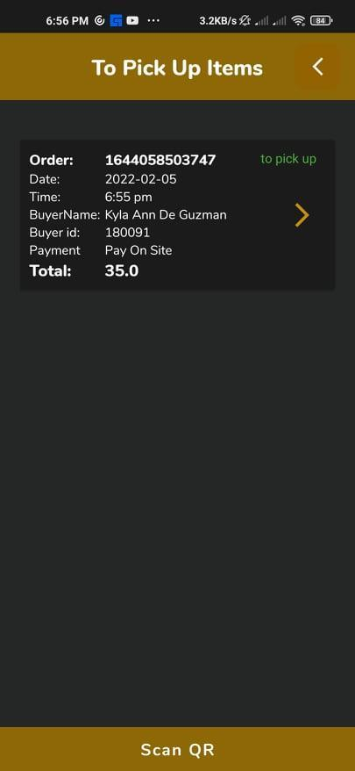
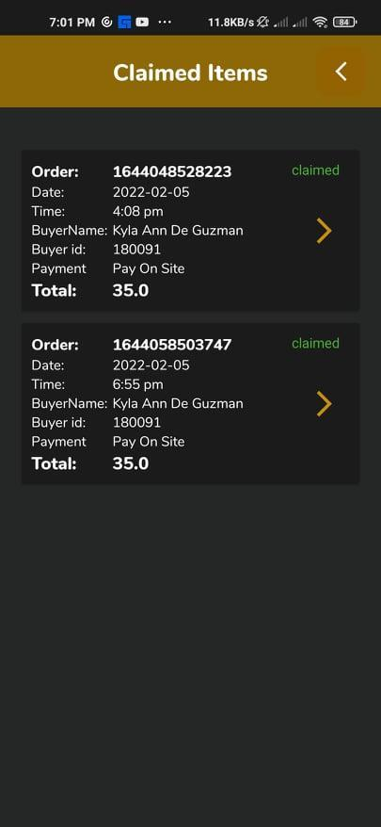

Figure 22: Product add to cart Output
In the figures above, Figure 1 shows the output when the user tap the ”Add to cart” button the system will show notification. Figure 2 show the order after the buyer tap the “Check Out” button to proceed to Figure 3 the “In queue Items” where it shows the buyer purchased meal. The Figure 4 show the “To Pick Up Items” and scan the order by using QR Code Scanner. The Figure 5 show all the “Claimed” items by the buyer.

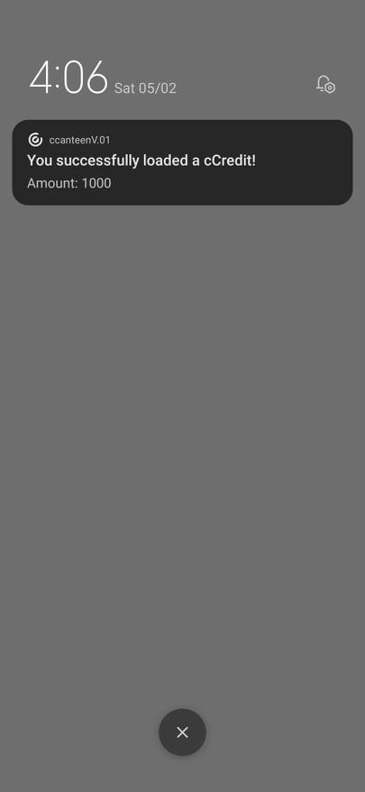
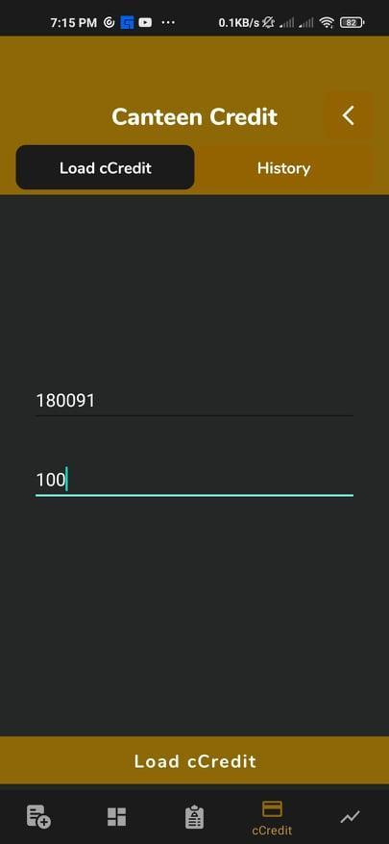
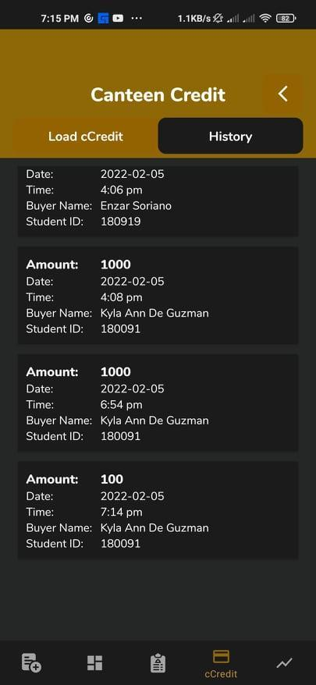

Figure 23: Ccredit output
In the figure 10 above, it shows the output when the user wanted to buy meal; they need ccredit to purchase an order. The seller is the only one who can load the ccredit of the buyer by typing the id number of the buyer and the amount requested of the buyer. Notification will receive once the process is successful and record the credit process in the “Canteen Credit History”.

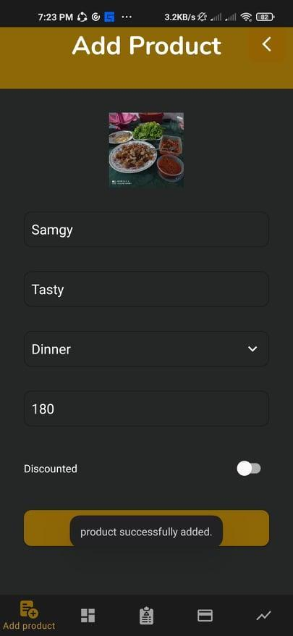
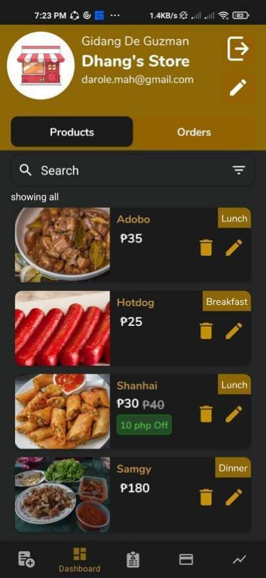
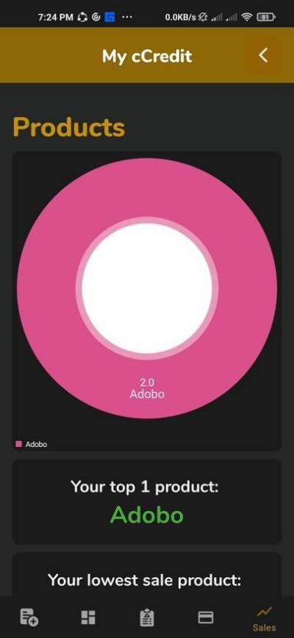
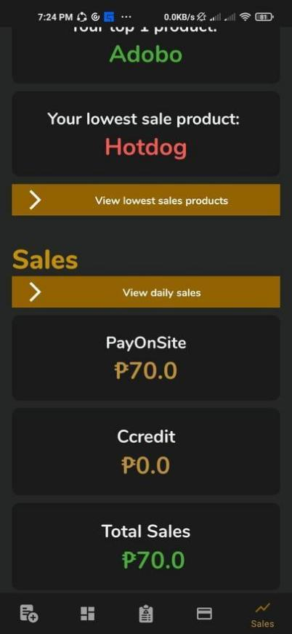

Figure 24: Seller Main Screen Output
In the figure 10 above, The Figure 1 show how the seller creating a meal to be post to the buyer’s menu. The Figure 2 show all the Sellers Product to know what are need to remove or to add a meal. The Figure 3 view the top products of the seller while in the Figure 4 view the lowest sales product, Sales “View Daily Sales” to know who used the “Pay On Site”a and “Ccredit” Method. Also, can View the Total sales of the Seller.

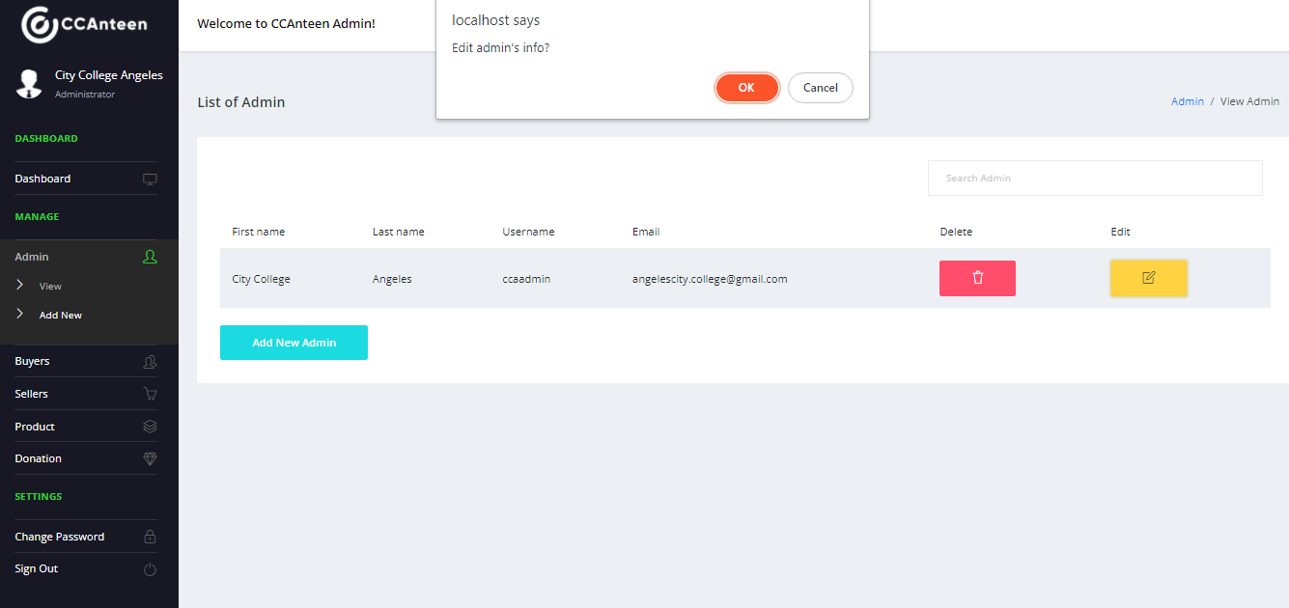
Figure 25: Admin Site Edit
Admin users can edit the data in buyers, sellers, and admins information. In this way any error on the users side can be edited in the admin site.
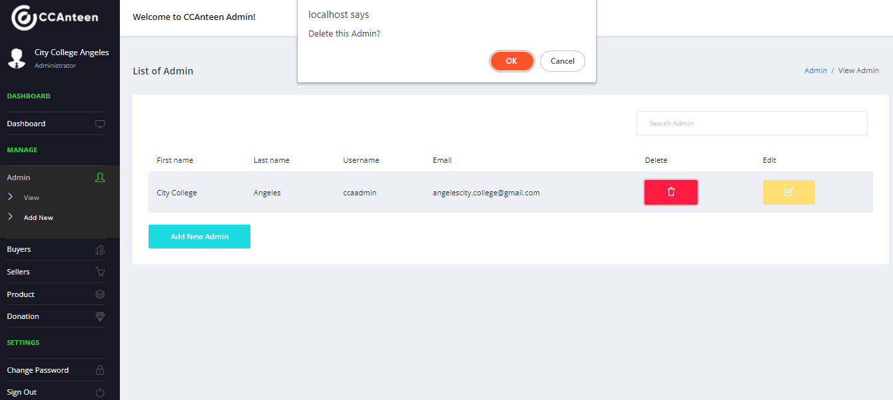
Figure 26: Admin Site Delete
Admin users can delete the data of buyers, seller, and admins. We added this delete prompt to make sure that the admin is notified that he/she is going to wipe off the data. If the buyer is graduated, his/her account will be deleted, while seller account will also be deleted only if they want to stop selling in the canteen.

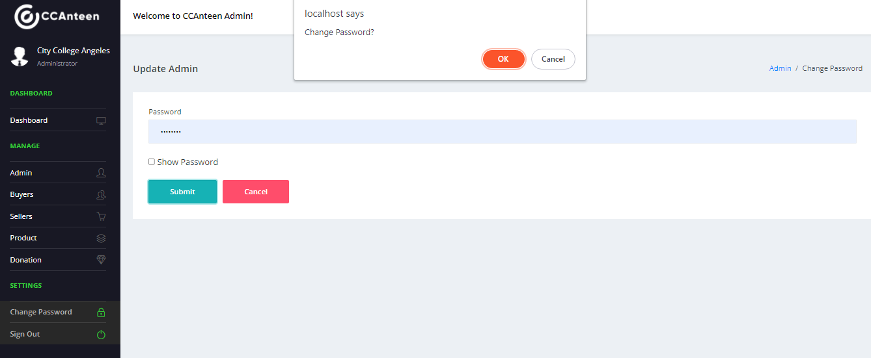
Figure 27: Admin Site Change Password
Admin users can change their password in their admin account. Just put the new password, and if the admin user wants to make sure his/her password before submitting it, there’s a checkbox option to visible the password.

Evaluation Results
In this evaluation results, the table 7 and 8 discusses the result of the evaluations from the participants including the three I.T. Experts with the use of ISO-25010 as a survey tool in collecting data. The study has 122 Non – I.T. and Three I.T. Experts with a total of 125 respondents. It shows that most of the participants are in Institute of Computing Studies and Library Information Science who comprise 36.2% of the whole respondents.

Table 7: Evaluation Results of I.T. Experts
Criteria | Mean | Descriptive Rating
Functional Suitability | 4.67 | Excellent
Performance Efficiency | 4.44 | Excellent
Compatibility | 4.00 | Very Good
Usability | 3.95 | Very Good
Reliability | 4.42 | Excellent
Security | 4.27 | Excellent
Maintainability | 4.47 | Excellent
Portability | 4.67 | Excellent
Overall Mean | 4.36 | Excellent

Table 7 presents the results of the evaluation completed by three I.T. specialists. The table displays the mean for each criterion, as well as its qualitative interpretation and ranking. The overall mean of the evaluation scores for software performance was 4.36, which corresponds to Excellent. This suggests that the system satisfies the user's needs, is dependable, simple to use, efficient with resources, and simple to maintain and manage.
The system's Functional Suitability received a score of 4.67, which is considered excellent. This demonstrates that the system has accomplished its primary goal, which is further defined by its completeness, correctness, and appropriateness.
Performance Efficiency was received a score of 4.44, which is considered excellent. This clearly demonstrates that the system has accomplished its primary goal, as evidenced by its operational behavior, resource efficiency, and capacity.
The compatibility was scored a 4 out of 5, which is considered very good. This clearly demonstrates that the system has accomplished its primary goal, which is further defined by its appropriateness, learnability, operability, user error protection, user interface aesthetics, and accessibility.
Usability was given a 3.95 rating, which is considered very good. This demonstrates that users and evaluators alike considered the system to be learnable and simple to use, independent of their prior experience with computers and systems in general. This also indicates that the system's graphical user interface is well-designed and appealing.
The system's reliability performance was scored 4.42, which is an excellent result. This demonstrates that the system has accomplished its primary goal, which is further defined by its maturity, availability, and fault tolerance.
The confidentiality, integrity, accountability, and authenticity of a system are all Security characteristics of software. This attribute received a grade of 4.27, which is considered excellent.
The system's maintainability function received a score of 4.47, which is considered excellent. Modularity, reusability, analyzability, modifiability, and testability are all indicators of system maintainability.
The system's portability was the final characteristic to be assessed. It received a 4.67, which is an excellent ranking in this category. This measure is broken down into sub-categories such as the system's ability to run on various platforms and environments, ease of installation and setup, compliance, and replaceability.
In ranking, Functional Suitability and Portability have the highest rating of 4.67. Followed by Maintainability with 4.47, Performance Efficiency with 4.44, Reliability with 4.42, Security with 4.27, Compatibility with 4, and getting the lowest is Usability with 3.95 rating.
Among the metrics that were used in ISO 25010 Functional Suitability has the highest score in Non – I.T. Experts while Functional Suitability and Portability has a highest score in I.T. Experts.

Criteria | Mean | Descriptive Rating
Functional Suitability | 4.28 | Excellent
Performance Efficiency | 4.18 | Very Good
Usability | 4.20 | Excellent
Reliability | 4.12 | Very Good
Overall Mean | 4.20 | Excellent
Table 8: Evaluation Results of Non-I.T. Experts

Table 8 shows above, the result of the Non – I.T. The system was evaluated by experts, and 122 of the respondents were chosen to take part in the evaluation. The system received an overall mean of 4.20 from the known number of system evaluators, which corresponds to a very good grade. Only four characteristics were utilized because the other four were difficult for Non – I.T. Experts to judge.

The system's Functional Suitability received a score of 4.28, which is considered excellent. This demonstrates that the system has accomplished its primary goal, which is further defined by its completeness, correctness, and appropriateness.
Performance Efficiency was received a score of 4.18, which is considered very good. This clearly demonstrates that the system has accomplished its primary goal, as evidenced by its operational behavior, resource efficiency, and capacity.
Usability was given a 4.20 rating, which is considered excellent. This demonstrates that users and evaluators alike considered the system to be learnable and simple to use, independent of their prior experience with computers and systems in general. This also indicates that the system's graphical user interface is well-designed and appealing.
The system's reliability performance was scored 4.12, which is a very good result. This demonstrates that the system has accomplished its
Based on the combined evaluations of its users, and I.T specialists, the program is thought to have an acceptable rating. It means that the program has a good acceptance level among the respondents. In order to quantify this Excellent rating, the overall mean must be at least 4.20 to 5.

DISCUSSION
In this chapter discusses the all part of the discussion. It includes the summary of findings, conclusions and recommendations to improve the quality and functions of the system.

Summary of Findings
This study discusses how this research is all about. The researchers decided to create online ordering system where only the City College of Angeles student, teachers and stuffs can use the application created by the researchers. To avoid social distancing, the researchers create (2) way payment method to lessen the waiting time in the canteen area. Gathering data to show how the research is more reliable based on what we gathered in to the internet and strengthen the paper. The conceptual framework of the research discusses how the application is being process and what is the flow of the system. The researcher used (2) algorithm F.C.F.S (First Come First Serve) that is for the seller part and for the buyer part is scheduling algorithm which is F.I.F.O (First In First Out). The method in research design used is Descriptive Research Design to know the major problem of every seller and buyer in City College of Angeles canteen. The researchers used agile model to finalized, planned design, to program the application, after the program they were going to testing it for bugs to be fixed, and once the application is done the researchers will deploy it together information about the application performance. For the participants the researchers limit the application to those people of the CCA. The hardware specification used in the application is only for android user and the researchers used desktop computer to create the application. For software specification, for coding the researchers used Microsoft Visual Studio Code. The System/ Application Output shows all the result of every transaction being done. While the researchers are doing all the needs of application, they distributed questionnaire to know the majority result of the application. When the result has been done, the researchers start their final steps to accomplished all the requirements.

Conclusions
We believed that if there is a problem, there is a solution. With the spread of corona-virus and other variants of virus, people who are mostly at the crowded place are likely to be prone in the virus. There's a lot of reason why the canteen has a long line, one of the reasons of that is that customer is waiting for their order to be prepared, beside that some of the customer has a large bill, and seller does not have any enough coins for change. There's are also products that has lower sales, which is a financial loss of the sellers. There is student who is not eating their lunch or on time due to lack of money to buy a meal. With AI Ordering application, the customer can now create a pre-order with their choice of payment method and no longer need to wait in the long lines. Seller will be notified about the lowest sale product, which they can give a discount to it which will increase the sale. And for the students who does not have enough money for the meal, there's donation box which someone else will pay for it.

Recommendations
In this part of the study, the researchers will state the recommendations to improve the functions and design for the application. Additionally, the recommendations are based on the limitation of the study, evaluation of the participants including the three I.T. Experts and to the conclusion. The I.T Experts suggests to add push notification on customers and sellers end, add multiple mode of payment such as bank transfer, improve the design to make it more encouraging and pleasing to the eye, and add options for extra condiments or add ons such as sauce, calamansi, chili etc.). While the researchers suggest to include how to cancel order and to see product's available stock, make the design and color more appetizing, suggest to try to look for an alternative way to place an order with a different seller because there are some circumstances where a buyer wants the meal from the first seller and also wants to buy another meal from another seller, and add ratings for the buyers and feedback for the sellers. The panelists suggest to make the ccredit to be centralize, in order for the buyer to use their balance credit to any sellers, they also suggested to make a cancel order feature if there’s an error on the buyer side. Researchers limited the feature and functions of the application, yet all the recommendations are noted which can be added in the future.

REFERENCES
Brigula, A. (2016, October). Nico A. Brigula. Retrieved from
https://capstoneguide.com/online-ordering-system-capstone-project-document/
Carlsson, H., Larsson, S., Svensson, Lupita., Åström, F. (2017). Hanna Carlsson, Stefan Larsson, Lupita Svensson, and Fredrik Åström. Retrieved from
https://connect.springerpub.com/highwire_display/entity_view/node/72626/full
Croasmun, J. and Ostrom, L. (2011, November). James T. Croasmun, Lee Ostrom. Retrived from
https://files.eric.ed.gov/fulltext/EJ961998.pdf.
Gravrock, E.V. (2018, November 18). Einaras Von Gravrock. Retrieved from
https://www.forbes.com/sites/forbeslacouncil/2018/11/15/how-ai-empowers-the-evolution-of-the-internet/?sh=562c2e543256
Kent, J., (2020, March 17). Jessica Kent. Retrieved from
https://healthitanalytics.com/news/white-house-urges-ai-experts-to-develop-tools-for-covid-19-dataset
Kadak, U., Gurefe, Y., (2016, September 19). Ugur Kadak, Yusuf Gurefe. Retrieved from
https://downloads.hindawi.com/archive/2016/5416751.pdf
Martin, S. (2019, October 5). Sophia Martin. Retrieved from
https://towardsdatascience.com/top-12-ways-ai-is-revolutionizing-the-online-shopping-ecommerce-trends-9c3e98ef519c
Nilsen, P. (2020, March 19). Per Nilsen. Retrieved from
https://link.springer.com/chapter/10.1007/978-3-030-03874-8_3
Oke, A., Dawson, P. (2008, December 5). A Oke, Patrick Dawson. Retrieved from
https://ro.uow.edu.au/commpapers/503/
Online Ordering System. (2016, Sep 26). Retrieved from
https://studymoose.com/online-ordering-system-essay
Ponto, J., Oncol, J., (2015, March 6). Julie Ponto, J Adv Pract Oncol. Retrieved from
https://www.ncbi.nlm.nih.gov/pmc/articles/PMC4601897/
Rahman, H., Ashraf, M., Abrar, M., Mehmood, A., (2019, November 12). Hafiz Rahman, Mahmood Ashraf, Muhammad Abrar, Abid Mehmood. Retrieved from
https://www.ijert.org/a-review-of-the-usable-food-delivery-apps
Restaurant Ordering System. (n.d). Retrieved from
https://ordering4103.weebly.com/uploads/2/4/3/1/24312085/final_chapter_2.docx
Reynolds, K., (2021, February 24). Kerri Reynolds Retrieved from
https://www.weforum.org/agenda/2021/02/covid-19-increased-use-of-ai-here-s-why-its-here-to-stay/
Singh, A., Adithya, R., Kanade, V., Pathan, S. (2018 June). Abhishek Singh, Adithya R,
Sullivan, G., Artino, A., (2013, December 5). Gail M. Sullivan Anthony R. Artino, Jr. Retrieved from
https://www.ncbi.nlm.nih.gov/pmc/articles/PMC3886444/
Vaishnav Kanade, Prof. Salma Pathan. Retrieved from
https://www.irjet.net/archives/V5/i6/IRJET-V5I679.pdf
Willems, I., (2020, June 24). Ingo Willems. Retrieved from
https://dmexco.com/stories/using-ai-to-create-a-personalized-shopping-experience-in-online-retail/

APPENDICES

Appendix A: AI Ordering Application for City College of Angeles Survey
The survey was conducted on August 11, 2021 by the researchers to determine what adjustments or improvements we could offer to improve the quality of services in the School Canteen. We had 64 students who took the survey, and we asked them about their personal experiences ordering from the canteen (See Survey Results). The responses were also provided in an Excel spreadsheet by the researcher, which included the timestamp, questions, and responses of the respondents (See Appendix B).

Survey Results
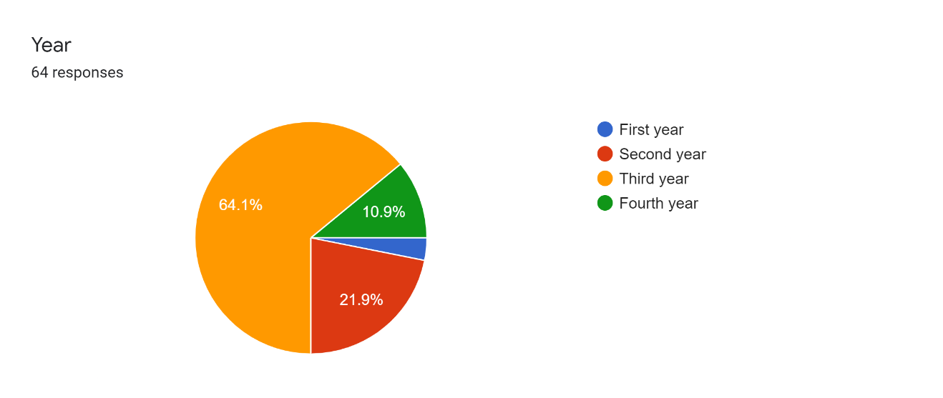
The respondents are mainly third year students, accounting for 64.1 percent of the study's total participants. It also shows that 21.9 percent of the respondents came from second year students, 10.9 percent from fourth year students, and the rest are first students.
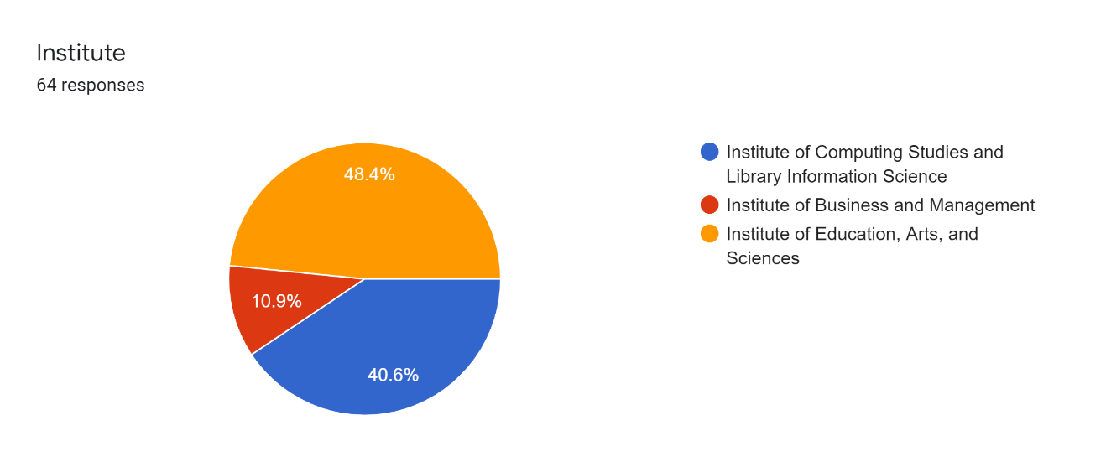
According to the results, 48.4 percent of respondents came from the Institute of Education, Arts and Sciences (IEAS). While 40.6 percent of the respondents came from the Institute of Computing Studies and Library Information Science (ICSLIS), and the remaining respondents came from the Institute of Business and Management (IBM). In summary, most of the respondents are students from ICSLIS.

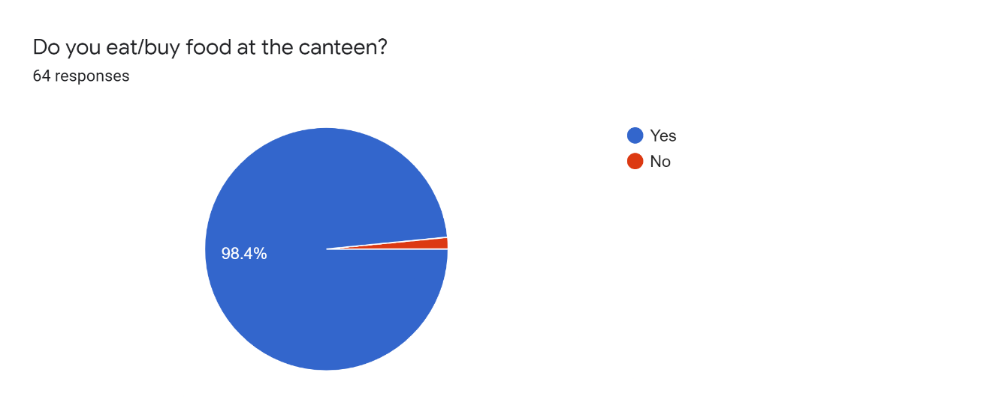
In this result, it shows that the majority of respondents, eat and buys food at the canteen. On the other hand, only 1.6 percent of the respondents does not buy food or eat at the Canteen.
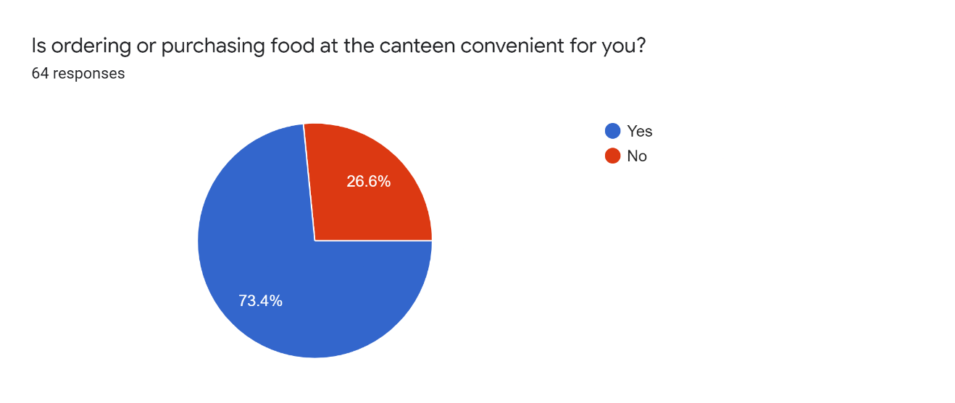
According to the research, 73.4 percent of respondents are that it is convenient to purchase food at the canteen, while only 26.6 percent stated that it is not convenient to purchase food at the canteen.

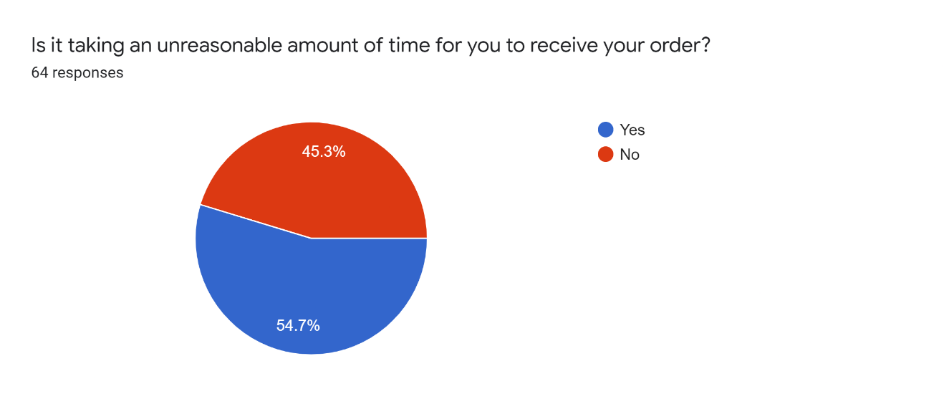
According to the data gathered, 54.7 percent of the respondents agreed that it takes an unreasonable amount of time to receive their order. Although, 45.3 percent disagreed as seen in results above.
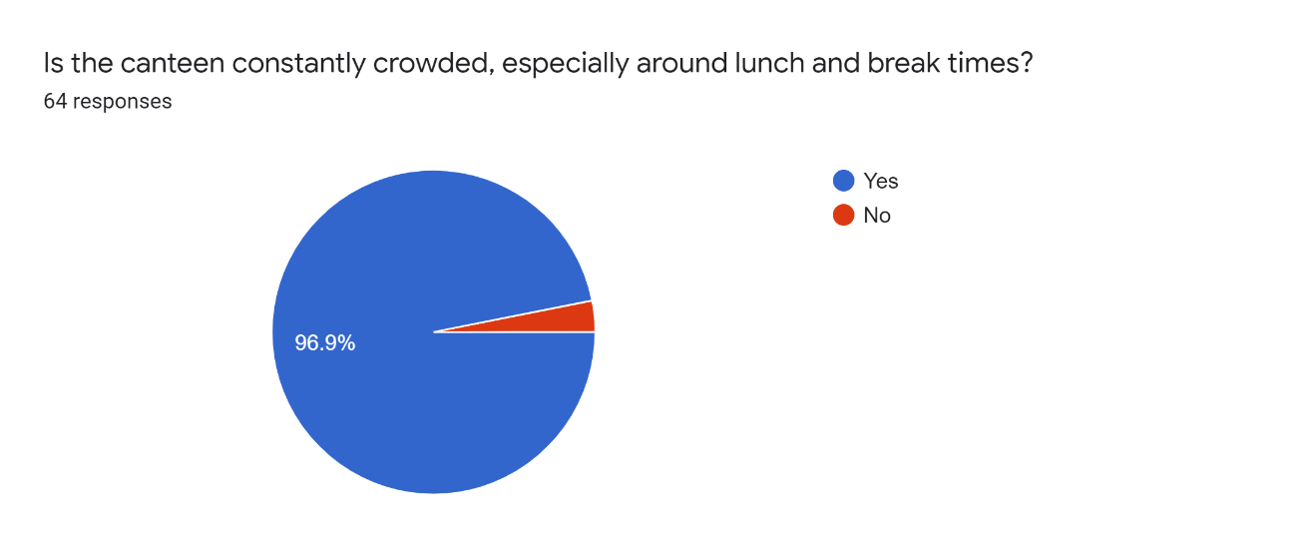
The results shows that the majority of respondents agreed that it is always crowded at the canteen especially during lunch and break.

Appendix B: Responses in Excel spreadsheet
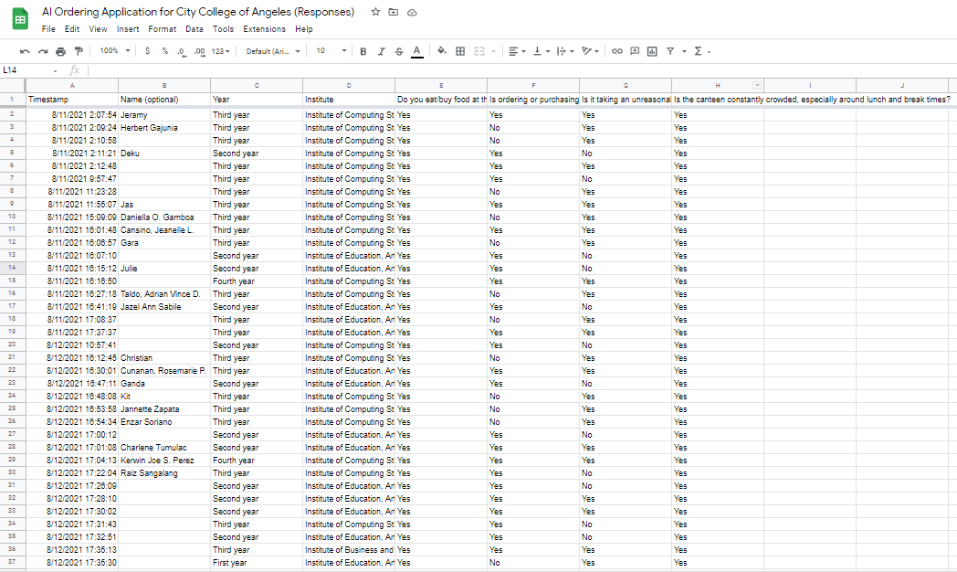

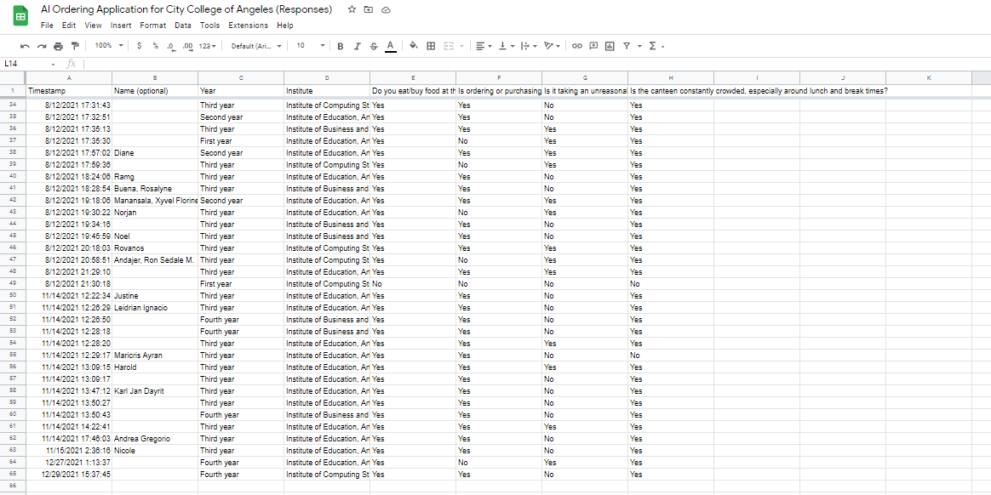

Appendix C: Evaluation Instrument for I.T Experts
Evaluation Instrument
(I.T. Experts)

Name (Optional): ______________ Age: ___________ Sex: ______________
Date Administered: Time: ______ Administered by:
Name of the Company:
Address:
Designation: _________________________ Department: ________________________

QUESTIONNAIRE
Please indicate a check mark (☑) under the column that best describes your responses for each item about the [name of your locale]. Please use the rating below:
Numerical Rating Equivalent
5 Excellent
4 Very Good
3 Good
2 Fair
1 Poor

INDICATORS | 5 | 4 | 3 | 2 | 1
- Functional Suitability
  - Functional completeness. Degree to which the set of functions covers all the specified tasks and user objectives.
  - Functional correctness. Degree to which a product or system provides the correct results with the needed degree of precision.
  - Functional appropriateness. Degree to which the functions facilitate the accomplishment of specified tasks and objectives.
- Performance efficiency
- Time behavior. Degree to which the response and processing times and throughput rates of a product or system, when performing its functions, meet requirements.
- Resource utilization. Degree to which the amounts and types of resources used by a product or system, when performing its functions, meet requirements.
- Capacity. Degree to which the maximum limits of a product or system parameter meet requirements.
- Compatibility
- Co-existence. Degree to which a product can perform its required functions efficiently while sharing a common environment and resources with other products, without detrimental impact on any other product.
- Interoperability. Degree to which two or more systems, products or components can exchange information and use the information that has been exchanged.
- Usability
- Appropriateness recognizability. Degree to which users can recognize whether a product or system is appropriate for their needs.
- Learnability. degree to which a product or system can be used by specified users to achieve specified goals of learning to use the product or system with effectiveness, efficiency, freedom from risk and satisfaction in a specified context of use.
- Operability. Degree to which a product or system has attributes that make it easy to operate and control.
- User error protection. Degree to which a system protects users against making errors.
- User interface aesthetics. Degree to which a user interface enables pleasing and satisfying interaction for the user.
- Accessibility. Degree to which a product or system can be used by people with the widest range of characteristics and capabilities to achieve a specified goal in a specified context of use.
- Reliability
- Maturity. Degree to which a system, product or component meets needs for reliability under normal operation.
- Availability. Degree to which a system, product or component is operational and accessible when required for use.
- Fault tolerance. Degree to which a system, product or component operates as intended despite the presence of hardware or software faults.
- Recoverability. Degree to which, in the event of an interruption or a failure, a product or system can recover the data directly affected and re-establish the desired state of the system.
- Security
- Confidentiality. Degree to which a product or system ensures that data are accessible only to those authorized to have access.
- Integrity. Degree to which a system, product or component prevents unauthorized access to, or modification of, computer programs or data.
- Non-repudiation. degree to which actions or events can be proven to have taken place, so that the events or actions cannot be repudiated later.
- Accountability. Degree to which the actions of an entity can be traced uniquely to the entity.
- Authenticity. Degree to which the identity of a subject or resource can be proved to be the one claimed.
- Maintainability
- Modularity. Degree to which a system or computer program is composed of discrete components such that a change to one component has minimal impact on other components.
- Reusability. Degree to which an asset can be used in more than one system, or in building other assets.
- Analyzability. Degree of effectiveness and efficiency with which it is possible to assess the impact on a product or system of an intended change to one or more of its parts, or to diagnose a product for deficiencies or causes of failures, or to identify parts to be modified.
- Modifiability. Degree to which a product or system can be effectively and efficiently modified without introducing defects or degrading existing product quality.
- Testability. Degree of effectiveness and efficiency with which test criteria can be established for a system, product or component and tests can be performed to determine whether those criteria have been met.
H. Portability
- Adaptability. Degree to which a product or system can effectively and efficiently be adapted for different or evolving hardware, software or other operational or usage environments.
- Install ability. Degree of effectiveness and efficiency with which a product or system can be successfully installed and/or uninstalled in a specified environment.
- Replaceability. Degree to which a product can replace another specified software product for the same purpose in the same environment.

Appendix D: Frequency Count of Distribution for I.T Experts
Evaluation Instrument
(I.T. Experts)

Name (Optional): ______________ Age: ___________ Sex: ______________
Date Administered: Time: ______ Administered by:
Name of the Company:
Address:
Designation: _________________________ Department: ________________________

QUESTIONNAIRE
Please indicate a check mark (☑) under the column that best describes your responses for each item about the [name of your locale]. Please use the rating below:
Numerical Rating Equivalent
5 Excellent
4 Very Good
3 Good
2 Fair
1 Poor

INDICATORS | 5 | 4 | 3 | 2 | 1
- Functional Suitability
- Functional completeness. Degree to which the set of functions covers all the specified tasks and user objectives. | 2 | 1 | 0 | 0 | 0
- Functional correctness. Degree to which a product or system provides the correct results with the needed degree of precision. | 2 | 1 | 0 | 0 | 0
- Functional appropriateness. Degree to which the functions facilitate the accomplishment of specified tasks and objectives. | 2 | 1 | 0 | 0 | 0
- Performance efficiency
- Time behavior. Degree to which the response and processing times and throughput rates of a product or system, when performing its functions, meet requirements. | 1 | 2 | 0 | 0 | 0
- Resource utilization. Degree to which the amounts and types of resources used by a product or system, when performing its functions, meet requirements. | 2 | 1 | 0 | 0 | 0
- Capacity. Degree to which the maximum limits of a product or system parameter meet requirements. | 1 | 2 | 0 | 0 | 0
- Compatibility
- Co-existence. Degree to which a product can perform its required functions efficiently while sharing a common environment and resources with other products, without detrimental impact on any other product. | 2 | 0 | 1 | 0 | 0
- Interoperability. Degree to which two or more systems, products or components can exchange information and use the information that has been exchanged. | 0 | 2 | 1 | 0 | 0
- Usability
- Appropriateness recognizability. Degree to which users can recognize whether a product or system is appropriate for their needs. | 1 | 2 | 0 | 0 | 0
- Learnability. degree to which a product or system can be used by specified users to achieve specified goals of learning to use the product or system with effectiveness, efficiency, freedom from risk and satisfaction in a specified context of use. | 2 | 1 | 0 | 0 | 0
- Operability. Degree to which a product or system has attributes that make it easy to operate and control. | 1 | 2 | 0 | 0 | 0
- User error protection. Degree to which a system protects users against making errors. | 0 | 2 | 1 | 0 | 0
- User interface aesthetics. Degree to which a user interface enables pleasing and satisfying interaction for the user. | 0 | 0 | 3 | 0 | 0
- Accessibility. Degree to which a product or system can be used by people with the widest range of characteristics and capabilities to achieve a specified goal in a specified context of use. | 0 | 2 | 1 | 0 | 0
- Reliability
- Maturity. Degree to which a system, product or component meets needs for reliability under normal operation. | 2 | 1 | 0 | 0 | 0
- Availability. Degree to which a system, product or component is operational and accessible when required for use. | 2 | 1 | 0 | 0 | 0
- Fault tolerance. Degree to which a system, product or component operates as intended despite the presence of hardware or software faults. | 1 | 1 | 1 | 0 | 0
- Recoverability. Degree to which, in the event of an interruption or a failure, a product or system can recover the data directly affected and re-establish the desired state of the system. | 2 | 0 | 1 | 0 | 0
- Security
- Confidentiality. Degree to which a product or system ensures that data are accessible only to those authorized to have access. | 2 | 0 | 1 | 0 | 0
- Integrity. Degree to which a system, product or component prevents unauthorized access to, or modification of, computer programs or data. | 2 | 0 | 1 | 0 | 0
- Non-repudiation. degree to which actions or events can be proven to have taken place, so that the events or actions cannot be repudiated later. | 1 | 1 | 1 | 0 | 0
- Accountability. Degree to which the actions of an entity can be traced uniquely to the entity. | 1 | 0 | 2 | 0 | 0
- Authenticity. Degree to which the identity of a subject or resource can be proved to be the one claimed. | 3 | 0 | 0 | 0 | 0
- Maintainability
- Modularity. Degree to which a system or computer program is composed of discrete components such that a change to one component has minimal impact on other components. | 1 | 1 | 0 | 1 | 0
- Reusability. Degree to which an asset can be used in more than one system, or in building other assets. | 2 | 1 | 0 | 0 | 0
- Analyzability. Degree of effectiveness and efficiency with which it is possible to assess the impact on a product or system of an intended change to one or more of its parts, or to diagnose a product for deficiencies or causes of failures, or to identify parts to be modified. | 2 | 0 | 1 | 0 | 0
- Modifiability. Degree to which a product or system can be effectively and efficiently modified without introducing defects or degrading existing product quality. | 2 | 1 | 0 | 0 | 0
- Testability. Degree of effectiveness and efficiency with which test criteria can be established for a system, product or component and tests can be performed to determine whether those criteria have been met. | 3 | 0 | 0 | 0 | 0
H. Portability
- Adaptability. Degree to which a product or system can effectively and efficiently be adapted for different or evolving hardware, software or other operational or usage environments. | 3 | 0 | 0 | 0 | 0
- Install ability. Degree of effectiveness and efficiency with which a product or system can be successfully installed and/or uninstalled in a specified environment. | 2 | 1 | 0 | 0 | 0
- Replaceability. Degree to which a product can replace another specified software product for the same purpose in the same environment. | 2 | 0 | 1 | 0 | 0

Appendix E: Frequency Count Distribution and Percentage of I.T Experts
Table 9: Accuracy of the system in terms of functional suitability
Factors | Frequency | Percentage
Excellent | 2 | 66.67%
Very Good | 1 | 33.33%
Good | 0 | 0
Fair | 0 | 0
Poor | 0 | 0
Total | 3 | 100%

Table 10: Accuracy of the system in terms of performance efficiency
Factors | Frequency | Percentage
Excellent | 1.3 | 43.33%
Very Good | 1.67 | 55.67%
Good | 0 | 0
Fair | 0 | 0
Poor | 0 | 0
Total | 3 | 100%

Table 11: Accuracy of the system in terms of compatibility
Factors | Frequency | Percentage
Excellent | 1 | 33.33%
Very Good | 1 | 33.33%
Good | 1 | 33.33%
Fair | 0 | 0
Poor | 0 | 0
Total | 3 | 100%

Table 12: Accuracy of the system in terms of usability
Factors | Frequency | Percentage
Excellent | 0.67 | 22.33%
Very Good | 1.5 | 50%
Good | 0.83 | 27.67%
Fair | 0 | 0
Poor | 0 | 0
Total | 3 | 100%
Table 13: Accuracy of the system in terms of reliability
Factors | Frequency | Percentage
Excellent | 1.75 | 58.33%
Very Good | 0.75 | 25%
Good | 0.5 | 16.67%
Fair | 0 | 0
Poor | 0 | 0
Total | 3 | 100%

Table 14: Accuracy of the system in terms of security
Factors | Frequency | Percentage
Excellent | 1.8 | 60%
Very Good | 0.2 | 6.67%
Good | 1 | 33.33%
Fair | 0 | 0
Poor | 0 | 0
Total | 3 | 100%

Table 15: Accuracy of the system in terms of maintainability
Factors | Frequency | Percentage
Excellent | 2 | 66.66%
Very Good | 0.6 | 20%
Good | 0.2 | 6.67%
Fair | 0.2 | 6.67%
Poor | 0 | 0
Total | 3 | 100%
Table 16: Accuracy of the system in terms of portability
Factors | Frequency | Percentage
Excellent | 2.33 | 76.67%
Very Good | 0.33 | 11.11%
Good | 0.33 | 11.11%
Fair | 0 | 0
Poor | 0 | 0
Total | 3 | 100%

Appendix F: Evaluation Instrument for Non-IT Experts
Evaluation Instrument
(NON- I.T. Experts)

Name (Optional): ______________ Age: ___________ Sex: ______________
Date Administered: Time: ______ Administered by:
Name of the Company:
Address:
Designation: _________________________ Department: ________________________

QUESTIONNAIRE
Please indicate a check mark (☑) under the column that best describes your responses for each item about the [name of your locale]. Please use the rating below:
Numerical Rating Equivalent
5 Excellent
4 Very Good
3 Good
2 Fair
1 Poor

INDICATORS | 5 | 4 | 3 | 2 | 1
- Functional Suitability
  - Functional completeness. Degree to which the set of functions covers all the specified tasks and user objectives.
  - Functional correctness. Degree to which a product or system provides the correct results with the needed degree of precision.
  - Functional appropriateness. Degree to which the functions facilitate the accomplishment of specified tasks and objectives.
- Performance efficiency
- Time behavior. Degree to which the response and processing times and throughput rates of a product or system, when performing its functions, meet requirements.
- Resource utilization. Degree to which the amounts and types of resources used by a product or system, when performing its functions, meet requirements.
- Capacity. Degree to which the maximum limits of a product or system parameter meet requirements.
- Usability
- Appropriateness recognizability. Degree to which users can recognize whether a product or system is appropriate for their needs.
- Learnability. degree to which a product or system can be used by specified users to achieve specified goals of learning to use the product or system with effectiveness, efficiency, freedom from risk and satisfaction in a specified context of use.
- Operability. Degree to which a product or system has attributes that make it easy to operate and control.
- User error protection. Degree to which a system protects users against making errors.
- User interface aesthetics. Degree to which a user interface enables pleasing and satisfying interaction for the user.
- Accessibility. Degree to which a product or system can be used by people with the widest range of characteristics and capabilities to achieve a specified goal in a specified context of use.
- Reliability
- Maturity. Degree to which a system, product or component meets needs for reliability under normal operation.
- Availability. Degree to which a system, product or component is operational and accessible when required for use.
- Fault tolerance. Degree to which a system, product or component operates as intended despite the presence of hardware or software faults.
- Recoverability. Degree to which, in the event of an interruption or a failure, a product or system can recover the data directly affected and re-establish the desired state of the system.

Appendix G: Frequency Count of Distribution for Non- I.T Experts
Evaluation Instrument
(NON- I.T. Experts)

Name (Optional): ______________ Age: ___________ Sex: ______________
Date Administered: Time: ______ Administered by:
Name of the Company:
Address:
Designation: _________________________ Department: ________________________

QUESTIONNAIRE
Please indicate a check mark (☑) under the column that best describes your responses for each item about the [name of your locale]. Please use the rating below:
Numerical Rating Equivalent
5 Excellent
4 Very Good
3 Good
2 Fair
1 Poor

INDICATORS | 5 | 4 | 3 | 2 | 1
- Functional Suitability
- Functional completeness. Degree to which the set of functions covers all the specified tasks and user objectives. | 53 | 52 | 16 | 0 | 1
- Functional correctness. Degree to which a product or system provides the correct results with the needed degree of precision. | 49 | 52 | 20 | 0 | 1
- Functional appropriateness. Degree to which the functions facilitate the accomplishment of specified tasks and objectives. | 58 | 48 | 15 | 1 | 0
- Performance efficiency
- Time behavior. Degree to which the response and processing times and throughput rates of a product or system, when performing its functions, meet requirements. | 45 | 55 | 19 | 2 | 1
- Resource utilization. Degree to which the amounts and types of resources used by a product or system, when performing its functions, meet requirements. | 54 | 45 | 22 | 1 | 0
- Capacity. Degree to which the maximum limits of a product or system parameter meet requirements. | 43 | 54 | 22 | 3 | 0
- Usability
- Appropriateness recognizability. Degree to which users can recognize whether a product or system is appropriate for their needs. | 55 | 48 | 17 | 2 | 0
- Learnability. degree to which a product or system can be used by specified users to achieve specified goals of learning to use the product or system with effectiveness, efficiency, freedom from risk and satisfaction in a specified context of use. | 55 | 44 | 18 | 4 | 1
- Operability. Degree to which a product or system has attributes that make it easy to operate and control. | 55 | 46 | 19 | 2 | 0
- User error protection. Degree to which a system protects users against making errors. | 41 | 53 | 24 | 3 | 1
- User interface aesthetics. Degree to which a user interface enables pleasing and satisfying interaction for the user. | 50 | 52 | 17 | 2 | 1
- Accessibility. Degree to which a product or system can be used by people with the widest range of characteristics and capabilities to achieve a specified goal in a specified context of use. | 49 | 49 | 21 | 3 | 0
- Reliability
- Maturity. Degree to which a system, product or component meets needs for reliability under normal operation. | 42 | 59 | 20 | 1 | 0
- Availability. Degree to which a system, product or component is operational and accessible when required for use. | 52 | 45 | 23 | 1 | 1
- Fault tolerance. Degree to which a system, product or component operates as intended despite the presence of hardware or software faults. | 41 | 48 | 30 | 3 | 0
- Recoverability. Degree to which, in the event of an interruption or a failure, a product or system can recover the data directly affected and re-establish the desired state of the system. | 43 | 47 | 31 | 1 | 0

Appendix H: Frequency Count Distribution and Percentage of Non- I.T Experts
Table 17: Accuracy of the system in terms of functional suitability
Factors | Frequency | Percentage
Excellent | 53.33 | 43.71%
Very Good | 50.67 | 41.53%
Good | 17 | 13.93%
Fair | 0.33 | 0.27%
Poor | 0.67 | 0.55%
Total | 122 | 100%

Table 18: Accuracy of the system in terms of performance efficiency
Factors | Frequency | Percentage
Excellent | 47.33 | 38.80%
Very Good | 51.33 | 42.07%
Good | 21 | 17.21%
Fair | 2 | 1.64%
Poor | 0.33 | 0.27%
Total | 122 | 100%

Table 19: Accuracy of the system in terms of usability
Factors | Frequency | Percentage
Excellent | 50.83 | 41.66%
Very Good | 48.67 | 39.89%
Good | 19.33 | 15.84%
Fair | 2.67 | 2.19%
Poor | 0.50 | 0.41%
Total | 122 | 100%

Table 20: Accuracy of the system in terms of reliability
Factors | Frequency | Percentage
Excellent | 44.50 | 36.48%
Very Good | 49.75 | 40.78%
Good | 26 | 21.31%
Fair | 1.50 | 1.23%
Poor | 0.25 | 0.20%
Total | 122 | 100%

Appendix I: Data Flow Diagram Context Level 0
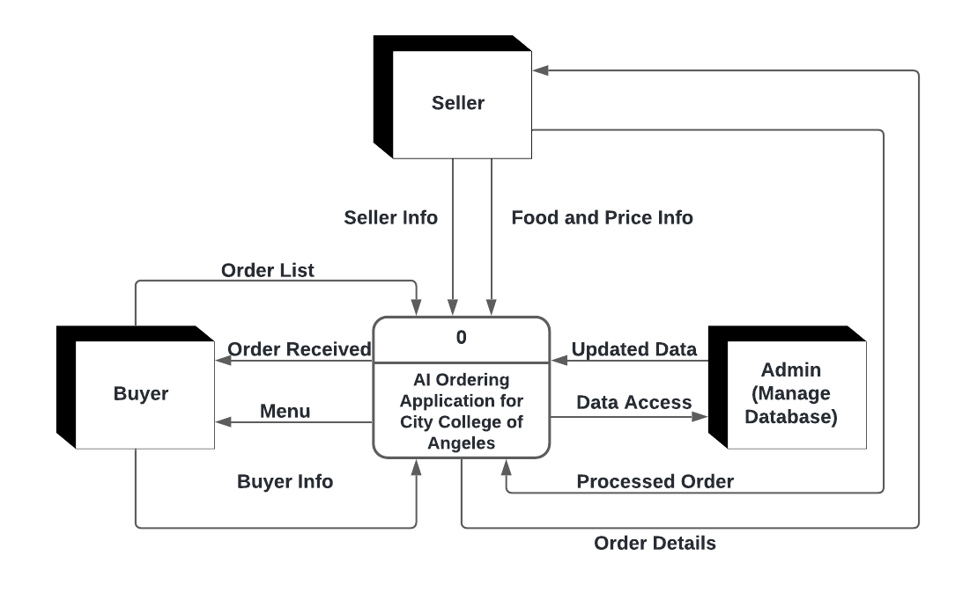

Appendix J: Data Flow Diagram Level 1
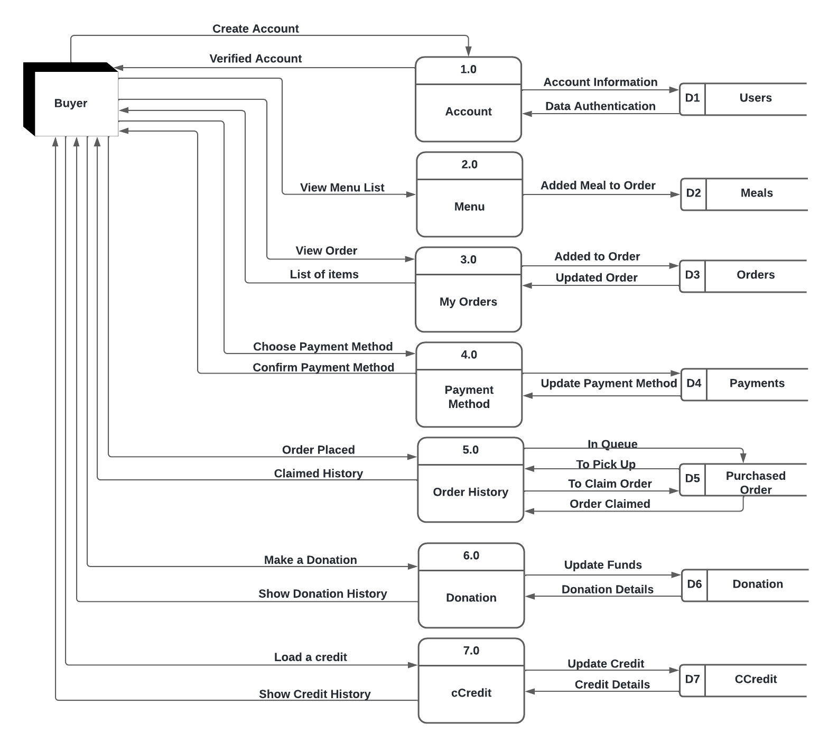
Level 1 Data Flow Diagram. (Buyer)

Level 1 Data Flow Diagram. (Seller)
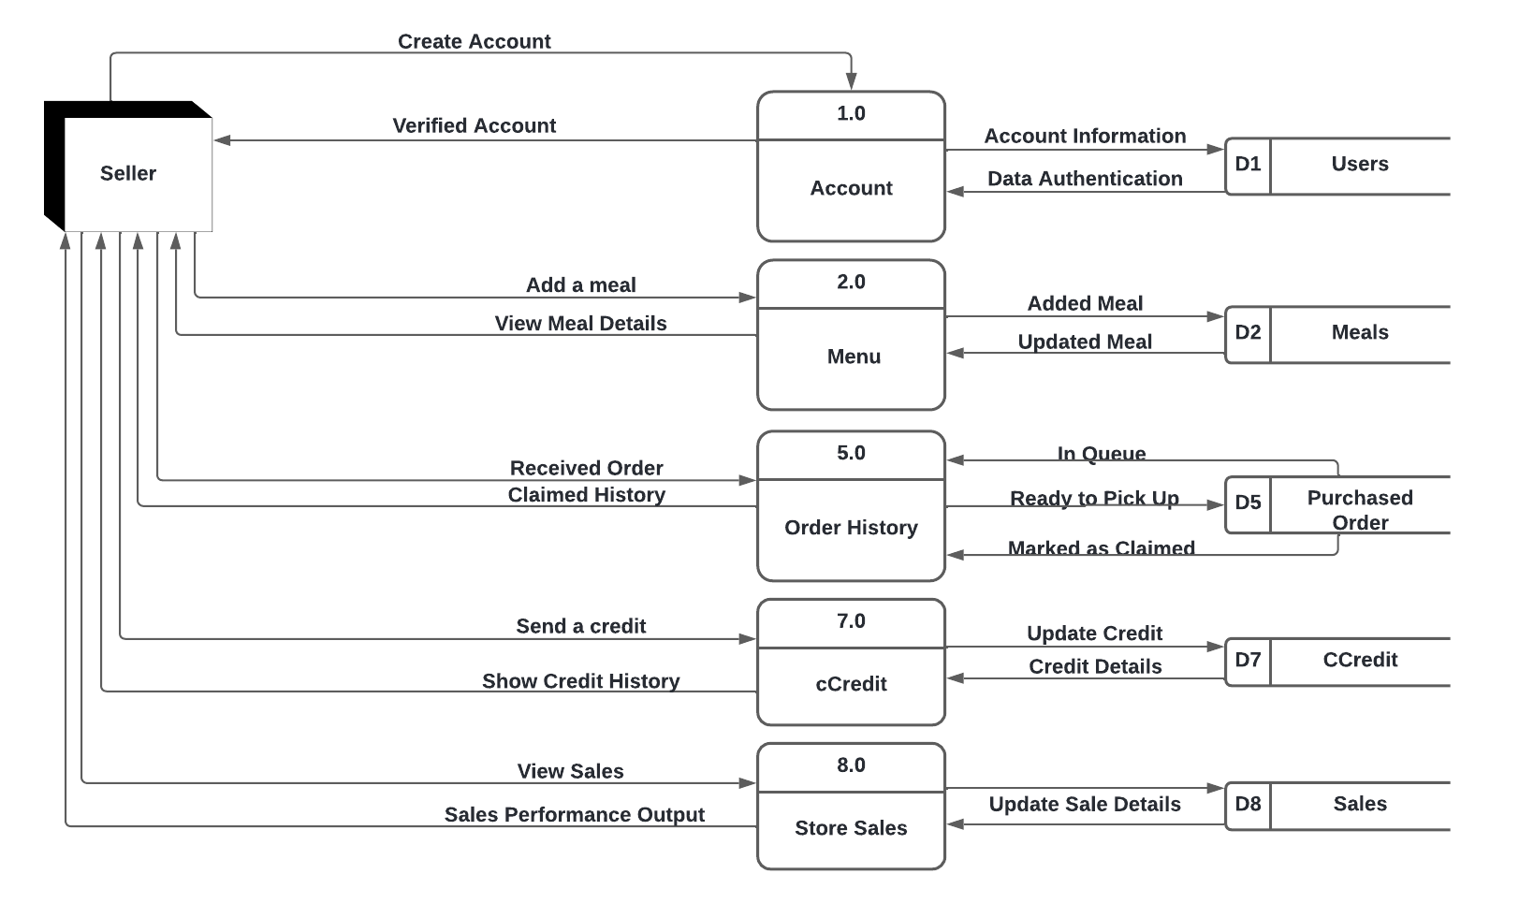

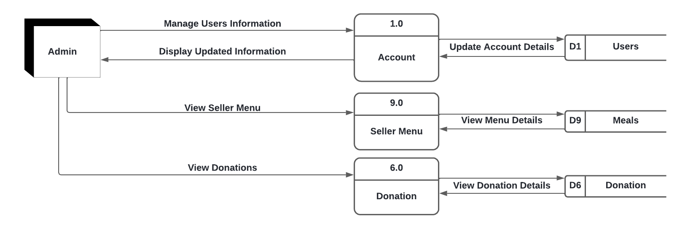
Level 1 Data Flow Diagram. (Admin)

Appendix K: Use Case Diagram
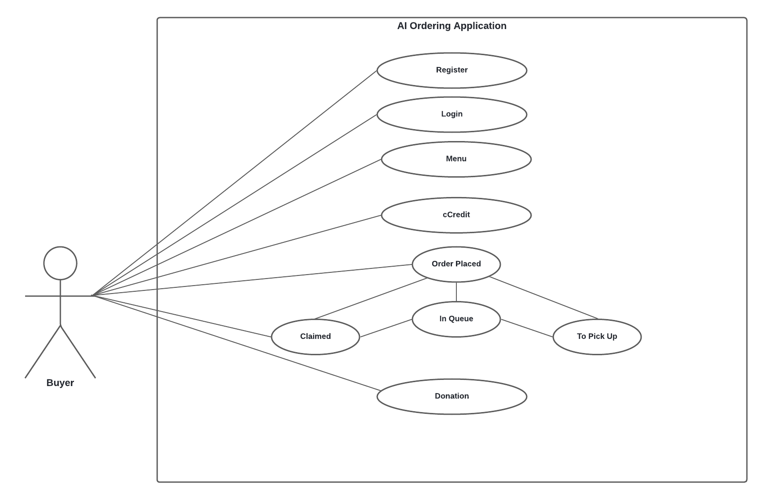
Use Case Diagram. (Buyer)

\
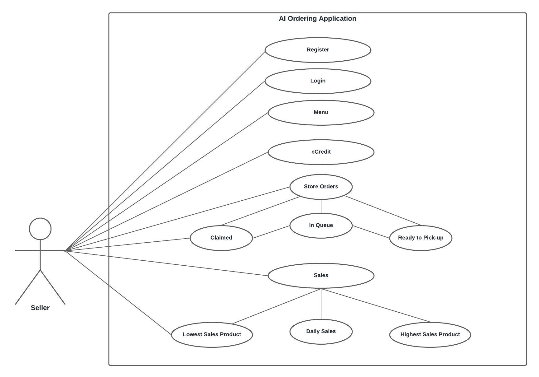
Use Case Diagram. (Seller)

Use Case Diagram. (Admin)
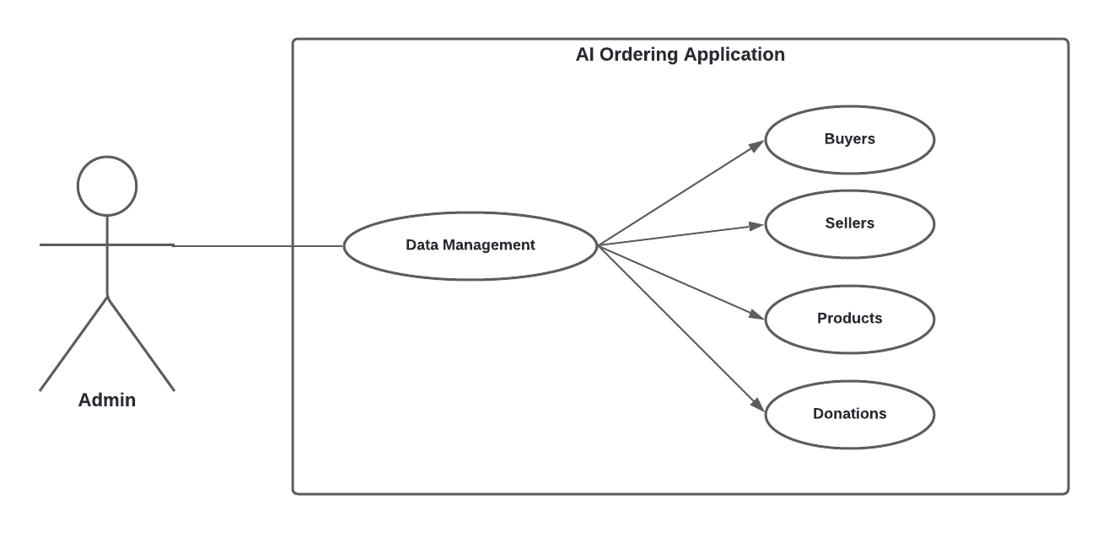

Appendix L: Flowchart
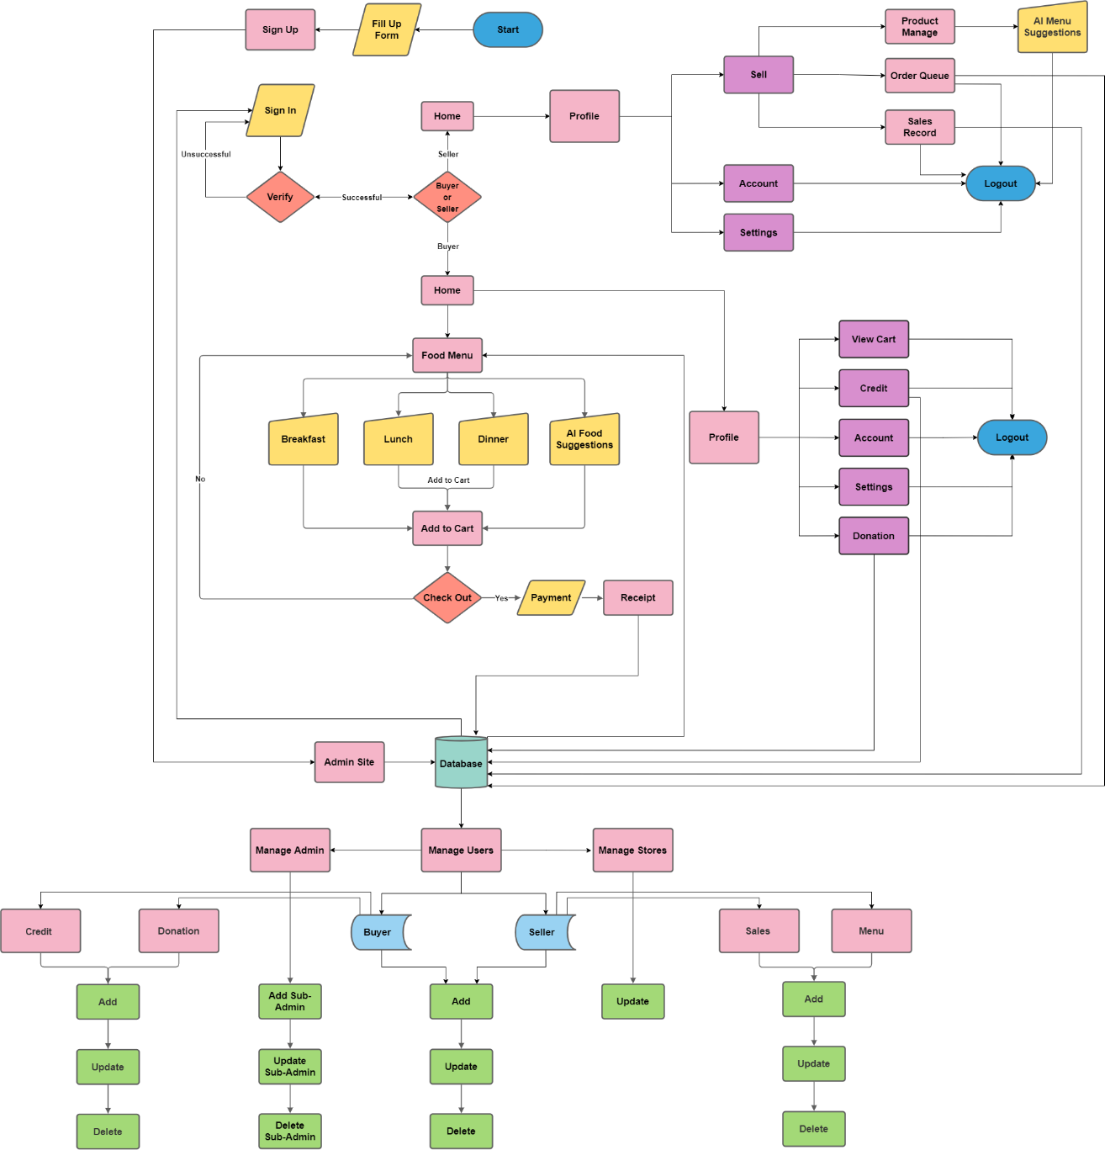


Appendix M: I.T. Experts Resume




Appendix N: Researcher’s Resume

DAROLE, ELMAR CONDEZ
Dist 4 Block 93 Lot 5 Epza Pulung Cacutud, Angeles City
Mayo.darole@gmail.com
0905-845-4259

OBJECTIVE
To showcase my ability and to explore more new things in work. Always active to every task that been given and open for more learning experience to improve as a professional. To gain trust and coordinate with my team as a professional worker.

PERSONAL INFORMATION
Age : 22 years old
Birthday : March 02, 1999
Gender : Male
Civil Status : Single

EDUCATION

City College of Angeles 2018 - Present
Bachelor of Science in Computer Science
Epza Pulung Cacutud, Angeles City

Bonifacio V. Romero High School (SHS) 2017 - 2018
Bonifacio V. Romero High School (JHS) 2015 - 2016
Epza Pulung Cacutud, Angeles City

Epza Resettlement Elemantary School 2011 - 2012
Epza Pulung Cacutud, Angeles City

ACHIVEMENTS
Microsoft Technology Associate (MTA) Passer
Introduction to Programming Using Java – Certified 2019
December 18, 2019

SKILLS
- Microsoft Office Applications such as Word, Powerpoint, Excel and Publisher
- Dedicated, determined and willing to learn and be trained
- Working well in a team
- Always having the initiative
- Verbal and personal communication skills

AFFILIATIONS
Organization Name: COMSOC
Position: Member
Year: 2018 – Present

SEMINARS ATTENDED
• Google I/O Extended Pampanga 2019,
Holy Angel University,
August 17, 2019.

• Entering the Freelancing Industry through FIVERR,
City College of Angeles, Angeles City Pampanga,
September 20, 2019.

• Introduction and Programming of Arduino,
City College of Angeles, Angeles City Pampanga,
September 20, 2019.

REFERENCES
- Ranice D. Garcia 0995-017-6110
Bonifacio V. Romero High School
Performing Arts Adviser (Teacher)

- Roberto G. Ignacio 0916-227-1440
Bonifacio V. Romero High School
Teacher

ELMAR C. DAROLE
Applicant’s Signature


Oliver Cruz Naguit
Block 56 Lot 3 District 6 EPZA Pulung Cacutud,
Angeles City, Pampanga
Naguit.oliver@gmail.com
09060642142
OBJECTIVES

To bring out and harness the best of my potentials for the glory of God and to obtain experience in a workplace environment.

PERSONAL INFORMATION

Age : 23 years old
Birthday : January 14, 1999
Gender : Male
Civil Status : Single

EDUCATIONAL BACKGROUND

Bachelor of Science in Computer Science
City College of Angeles
Barangay Pampang, Angeles City
August 2018 - Present

Senior High School
Bonifacio V. Romero Sr. High School
EPZA Resettlement, Pulung Cacutud, Angeles City
June 2016 – April 2018

Junior High School
Bonifacio V. Romero Sr. High School
EPZA Resettlement, Pulung Cacutud, Angeles City
June 2012 – March 2016

Elementary Education
EPZA Resettlement, Elementary School
EPZA Resettlement, Pulung Cacutud, Angeles City
June 2006 – April 2012

TRAININGS ATTENDED

Microsoft Technology Associate (MTA) Passer
Introduction to Programming Using Java – Certified 2019
December 18, 2019

PCAP - Programming Essentials in Python Passer
Programming Essentials in Python
21 Jan 2019 - 22 Jan 2020

PROFESSIONAL SKILLS
- Troubleshooting
- Programming using Different Languages
- Microsoft Visual Studio(VB)
- HTML and PHP
- Java
- Python
- Java Script
- Designing
- Figma
- Adobe XD
- Adobe Illustrator
SEMINARS ATTENDED

Robotics and Internet of Things
City College of Angeles, Angeles City Pampanga
September 20, 2018

Google I/O Extended Pampanga 2019
Holy Angel University
August 17, 2019

Agile Engineering -- Accommodating Change without Things Blowing Up
FILAM Software Technology, Angeles City Pampanga

August 29, 2019

OLIVER CRUZ NAGUIT
Applicant’s Signature


ENZAR L. SORIANO
46 Puri Street, Malabanias, Angeles City
elsoriano.cca@gmail.com
09269561328

OBJECTIVES

To bring out and harness the best of my potentials and to obtain experience in a workplace environment.

PERSONAL INFORMATION

Age : 19 years old
Birthday : February 04, 2000
Gender : Male
Civil Status : Single

EDUCATIONAL BACKGROUND

Elementary
Sta. Teresita Elementary School,
2006-2012.

Junior High School
Angeles City National Trade School,
2012-2016.

Senior High School
Angeles City National Trade School ,
2016-2018.

Tertiary
Bachelor of Science in Computer Science,
City College of Angeles,
2018.

ACHIEVEMENTS

- Microsoft Technology Associate (MTA),
Introduction to Programming Using Java - Certified 2019,
December 17, 2019 issued by Microsoft.

- National Certificate II,
Specialized in Electronic Product Assembly Servicing (EPAS),
April 17, 2018 - April 17, 2023.

- Distro Festival Competition (Linux Ubuntu) - Champion,
City College of Angeles, Angeles City Pampanga,
September 20, 2019.

- Capture The Flag (Cyber Security Competion)- Champion,
City College of Angeles, Angeles City Pampanga,
November 8, 2019.

SKILLS

- Strong Leadership
- High Confidence
- Excellent Communication
- Computer Literacy
- Disk Cloning
- Reformat Operating System
- Windows Configuration
- Linux Operating System
- Cisco Router
- Computer Hardware Troubleshooting
- Windows Troubleshooting
- Average typing speed of 60 wpm

- Basic Programming using Different Languages
- Java
- Python
- Android Studio
- Mysql

SEMINARS ATTENDED

- Pre-Employment Orientation Seminar,
Angeles City National Trade School, Angeles City Pampanga,
September 14, 2017.

- Robotics and Internet of Things,
City College of Angeles, Angeles City Pampanga,
September 20, 2018.

- Google I/O Extended Pampanga 2019,
Holy Angel University,
August 17, 2019.

- Agile Engineering -- Accommodating Change without Things Blowing Up,
FILAM Software Technology, Angeles City Pampanga,
August 29, 2019.

- Entering the Freelancing Industry through FIVERR,
City College of Angeles, Angeles City Pampanga,
September 20, 2019.

- Introduction and Programming of Arduino,
City College of Angeles, Angeles City Pampanga,
September 20, 2019.

WORK EXPERIENCE

- Converge ICT Solutions, Inc. ,
Field Maintenance (On the Job Training),
December 2018 (180 hours).

CHARACTER REFERENCE

- Ms. Cziarra Keith P. Pineda ,
Teacher in Angeles City National Trade School.

- Mr. Mark Superio ,
College Instructor in City College of Angeles.

I hereby declare that the details furnished above are true and correct to the best of my knowledge and belief and I undertake to inform you of any changes therein, immediately. In case any of the above information is found to be false or untrue or misleading or misrepresenting, I am aware that I may be held liable for it.

ENZAR SORIANO
Applicant’s Signature


JANNETTE G. ZAPATA
8b 8th St. Plaridel II Amsic, Angeles City
jannettejannine@gmail.com
09269465272

OBJECTIVES

To bring out and harness the best of my potentials for the glory of God and to obtain experience in a workplace environment.

PERSONAL INFORMATION

Age : 23 years old
Birthday : March 2, 1998
Gender : Female
Civil Status : Single

EDUCATIONAL BACKGROUND

Elementary
Malabanias Elementary School
2004-2010

Secondary
Rafael L. Lazatin Memorial High School
2010-2014

Tertiary
Information Technology
Asian Institute of E-Commerce
2014-2015

Information Technology
Systems Plus College Foundation (Miranda)
2016 (Graduate)

Bachelor of Science in Computer Science
City College of Angeles
2018

TRAININGS ATTENDED

NCIII Passer (Visual Graphics and Design)
Adobe, Corel Draw X3, Sketch Up
March 30, 2016

Sutherland Global Services
Encoder (On the Job Training)
June 2016 – October 2016 (300 hours)

Microsoft Technology Associate (MTA) Passer
Introduction to Programming Using Java – Certified 2019
December 18, 2019

PCAP -Programming Essentials in Python Passer
Programming Essentials in Python
21 Jan 2019 - 22 Jan 2020

PROFESSIONAL SKILLS
- Troubleshooting
- Programming using Different Languages
- Microsoft Visual Studio(VB)
- HTML and PHP
- Java
- Python
- Designing
- Adobe Photoshop CS6
- Sketch Up
- Corel Draw X3
- Macromedia Flash 8

SEMINARS ATTENDED

E-Commerce: A Major Factor in Nation Building
E-Commerce Convention 2015 (Quezon City)
March 5, 2015

Robotics and Internet of Things
City College of Angeles, Angeles City Pampanga
September 20, 2018

Google I/O Extended Pampanga 2019
Holy Angel University
August 17, 2019

Agile Engineering -- Accommodating Change without Things Blowing Up
FILAM Software Technology, Angeles City Pampanga
August 29, 2019

Entering the Freelancing Industry through FIVERR
City College of Angeles, Angeles City Pampanga
September 20, 2019

Introduction and Programming of Arduino
City College of Angeles, Angeles City Pampanga
September 20, 2019

ACHIEVEMENTS
9th I.T. Skills Olympics (Java Programming Competition) – Participant
University of Makati, City of Makati
September 9, 2019

Distro Festival Competition (Ubuntu) - Champion
City College of Angeles, Angeles City Pampanga
September 20, 2019

Capture the Flag Competition - Champion
City College of Angeles, Angeles City Pampanga
November 8, 2019
WORK EXPERIENCE

Sutherland Global Services
Customer Service Representative
October 15, 2016 – March 23, 2018

English as a Second Language (ESL)
English Teacher
July 2019

Hibro Wholesale
Online Data Encoder (Freelance)
June 2019

Madhat Media
Virtual Assistant

December 2020 – October 2021

JANNETTE ZAPATA

